
 | 8135 Lake Worth Rd. | Lake Worth, FL 33467  Ph.: 561.291.8113  mindfulstorage.com
RESERVE YOUR UNIT TODAY!

Security Self Storage Features:  - FREE Truck Rental at Move-In*  - Climate Controlled Units  - Drive Up Access  - Dollies & Carts Available  - 24 Hour Digital Recording System  - ALL GROUND LEVEL UNITS  - Coded Gate Access  - Month to Month Rentals  - Online Payment Available  - Boxes and Packing Supplies  - Boat & RV Parking up to 40 feet5 x 5's - 10 x 30's | 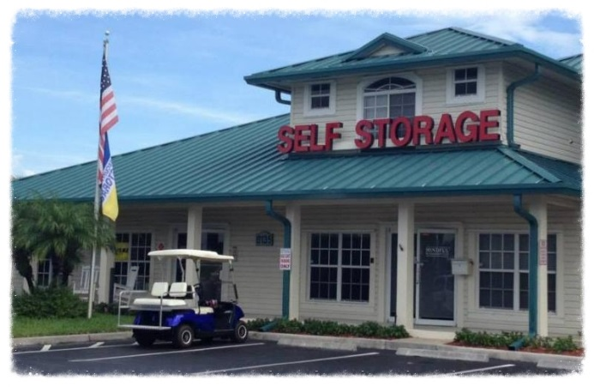Located 1 block West of Florida's Turnpike on Lake Worth Road in Lake Worth, Florida, serving students and faculty of Palm Beach State College, local businesses, and senior communities .

