1. **Call to Order – by President**
   1. Time- 5:00 PM
2. **Roll Call**

* 1. President – Chet Morrish
  2. Vice-President - David Temple
  3. Secretary - Kristin Ramos
  4. Treasurer – Eric Sandquist
  5. Equipment Manager - Louie Guizzetti
  6. Registrar (DOA) - Kim Sandquist
  7. Club Manager - Jani Morrish
  8. Director of Development – Taylor Anthony
  9. Director of Competition – Sean Carlson
  10. Director of Advertisement and Fundraising – Beth Janelle
  11. Board Member – Cami Krise
  12. Board Member – Brogan Nordness
  13. Guest –
  14. Guest –

1. **Approval of Previous Meeting Minutes – from both August and September**
   1. Motion to approve August- Brogan
   2. Second – Kim
      1. Discussion - None
   3. Carried – Unanimous
   4. Motion to approve September- Beth
   5. Second – Cami
      1. Discussion
   6. Carried – Unanimous
2. **Special Business**
   1. Board Meeting Attendance
      1. President spoke to Sean Carlson. Carlson will assemble a competitive committee to meet once a month. Either Sean or Chet will provide the meeting minutes to Kristin prior to the two day minimum before the monthly board meeting. If Sean is unwilling to commit to meetings and reporting, he should resign. He committed to participating as agreed.
   2. Resignation of DOAFs
      1. Thanks appreciated for effort.
   3. Kudos for Supermod Uniforms (Board/parents/kids/coaches)
      1. Families love the new jerseys – Manager emailed coaches recommending the coaches make signs to differentiating the teams from each other
   4. Nomination of New Board Member
      1. Kristin Ramos nominated Colleen Nordness for 3rd General Board Position
         1. Beth and Cami provided a second to the nomination
            1. Colleen Accepted the nomination via email
            2. President appointed her for the open board position
3. **E-mail Approvals / Communications Between Meetings**
   1. 3 Oct – Club manager requested assistance in picking up additional merchandise from Baydo’s – Club President to pick up merchandise
   2. 3 Oct – YCS requested that teams using RMS move around more on the field to avoid damage or else the field would have to be closed for a rest
      1. Black Hills Football practices on the field Tues-Thurs – Secretary recommended to the manager that she forward the information to YCS for them to contact BHYFL
   3. 2 Oct – Club Manager asked if there would be a sibling discount for the Gspurning Clinic
      1. One Board reply indicated since there is not discount for current club members, there should not be a discount for siblings, as this is a one-time event and not a season registration
   4. 30 Sept – PSC practice cancellation due to flooded fields
   5. 30 Sept – Board approval requested for club apology letter to TCYSA Club Manager, Debi Matthews – approved and sent
   6. 28 Sept – Flooded field email string - discussion
      1. Lakepoint was flooded and the scheduled games moved Black Hills
      2. At 10:34AM the affected coaches’ contact numbers were provided to Stephen Carrow to notify affected coaches of changes
      3. At 4:17PM Taylor Anthony sent the TCYSA Manager, Debi Matthews, an email claiming the field at Black Hills was not ready and that there was only one that was lined. He said the plan “failed miserably”. He further stated that the confusion “tarnished the image of TCYSA and PSC with two sets of team parents”
      4. At 3:27PM pm on the 29th, Debi Matthews responded to Taylor Anthony’s email explaining that alternate designated fields may not have been lined, but they had cones so that the two teams could play. Debi spent eight hours redirecting teams to usable fields due to flooded conditions at the originally scheduled locations.
      5. If there is a perceived problem with a field, what is the protocol for reporting and/or obtaining alternate field details?
         1. Do PSC Board members go through the PSC Manager and have her contact the TCYSA Manager, or is it appropriate for a club board member to contact another club manager directly?
         2. What is the appropriate chain of command/course of action for future similar situations?
   7. 26 Sept – President requested assistance with the delivery of pugs and equipment to SuperMod for Friday – Brogan arranged to meet with the President Friday evening
   8. 25 Sept – Gspurning Clinic Discussion
      1. Manager requested the Stadium Field for 8am set up and 9am event start time, with a 2pm end time and off the field by 3pm
         1. Stadium use approval email sent by club manager on 10/3
      2. Chet suggested the older group have the morning slot– additional discussion reversed older group to second session
      3. 9am-1030 am for U-8 – U-10 with a half hour break for autographs and pictures for the morning group ONLY
      4. 1100am-1pm is for U11-full field, with a half hour to get autographs and photos at the end.
      5. Cami suggested bumping capacity of both groups up to 25 slots, since there is no need for lights
         1. Dependent upon registration numbers?
      6. No parents whatsoever are allowed on the field – must stay in the stands until autograph and picture time
      7. The only photographer on the field during the clinic is the current club photographer, who should be present for both sessions
      8. Doug cost = $400 and Gspurning = $1000
         1. Recommended skills (U-11 and full field)
            1. Geometry of goal keeping (angles and positioning)
            2. How to direct defenders from the goal box (Keeper Leadership)
            3. Increasing comfort levels leaving the goal box
            4. Observing penalty kicker body language
            5. Catching vs deflecting higher velocity shots
            6. Other
         2. U8-U10
            1. Basic catching and blocking
            2. Rules for kick backs
            3. Effective and safe diving
            4. Positioning in and around the goal box for different height shots
            5. Other
      9. Unexpected expense is custodian on a Sunday
      10. Dinner raffle/late lunch with the Sounders Keepers – DISCUSSION
      11. Spirit Wear for the Sounders Keepers – DISCUSSION
      12. Registration due to open 1 October
          1. $45 for younger group; $90 for older group
   9. 23 Sept – Parent requested a waiver of the admin fee for a registration cancellation four days prior to the start of the season
      1. Four votes for refund
      2. Four votes against refund
      3. 1 vote supporting ½ refund compromise
      4. 1 vote against ½ refund compromise
         1. In the event of a tie vote, the decision falls on the club President
            1. Decision: On 9/25, the Club President made the decision to not provide a refund in an effort to keep more funds available for the players.
            2. **President is charged with voting to support policy ion every instance**
            3. **New policy proposal – coaches and asst coaches discount – coaches can get a full refund – no refunds for anyone for any reason**

**Board encouraged to think about a solution and revisit in the “new business” section**

* 1. 19 Sept – Flyer discussion: add prices, refund policy, and disclaimer about schools not assuming responsibility
  2. 19 Sept – Yelm Jamboree Tournament Discussion
     1. Consider the first to be a simple U8 – U10 boys and girls
        1. Possible for a spring season kick off in March
     2. Pay attention to details – President requests the competitive committee to meet and get the ball rolling
        1. Parents need to be made aware that THEY (parents) are the revue source for our club – the more funding goes in, the more resources can be provided to the club
           1. Promote spirit wear through the Winners link on the web site
     3. Louie distributed a planning sheet (at the end of this document)
        1. Board input and brainstorming
        2. What is the actual goal of the tournament?
           1. Increase local club participation?
           2. Get individual teams aware of tournament opportunities outside PSC?
           3. Make $ for the club?
        3. Sean Carlson provided input considerations via email on 10/2 (list in combined with categories on Louie’s planning sheet)
           1. Field costs and availability
           2. How many teams/age groups will the tournament support?
           3. How many different field sizes will we need?
           4. Referee costs
           5. Other direct costs

Calculate total tournament costs

* + - * 1. Age groups
        2. Which facilities can support this?
        3. Will we need to set a limit?
        4. Will it be open to other District 7 clubs?
        5. Merchandise
        6. Tournament rules

Only recreational teams – no select

* + - * 1. Prefer to be held prior to the start of spring season
    1. WYS should be consulted regarding the process for getting the Jamboree sanctioned
  1. 18 Sept – Manager inquired about SuperMod start
     1. Equipment was delivered; Brogan provided printouts; coaches picked up (one coach left after picking up equipment, leaving a parent to coach first practice/game); Calista Ramos to assist with the Tigers (Zaine Graves, Coach) when she is not playing for YHS, Brogan/David/Kristin packed up, and David took the goals with him.
     2. Jani secured last coach for U 6/7 and sent out start dates for first practice and games

1. **Unfinished Business**
   1. Summary of Coaches’ Clinics
      1. Should not be coming from individual board members. They should be coming from Taylor Anthony-then Taylor reports
   2. **VOTE NEEDED - TABLED**
      1. Elimination of Yelm FC program
      2. Keep in the bylaws for future implementation – PSC is a recreational club, first
         1. Wait for Sean to explore options and time to explore options prior to making a decision
   3. Board Jacket Status
      1. Distributed at the Board meeting – Kudos to Dave
   4. Rainier Soccer Fields
      1. Will be brought up at the next Rainier Council meeting
         1. City of Rainier is waiting on Thurston county MOU
   5. Board attendance at games
      1. David to identify games with teams to watch and let the board know when assistance is needed
         1. If there are issues with specific teams, David Temple will send an email blast to the Board
   6. Ruffneck scarves fundraiser status
      1. Too late for fall season – will revisit for spring season
         1. The more ordered the more money made
2. **New Business**
   1. Stakes for new pug goals needed
      1. David will contact Patrick about the pug quality issues and get back to the board about broken stakes and one broken pug
   2. Awards night proposal discussion
      1. Suggestion to mimic Washington Youth Soccer categories to be better able to submit nominees from the club to the district when the time comes
         1. Young female referee of the year
         2. Young male referee of the year
         3. Goal of the year
         4. Save of the year
         5. Boys rec coach of the year
         6. Girls rec coach of the year
         7. Admin/Board of the year
         8. Volunteer of the year
         9. Sportsmanship Award
         10. President’s Award
      2. Propose annual
         1. Nisqually said the club could use the Nisqually Sports center
3. **Officers Report**
   1. President – Chet Morrish
      1. TCYSA apology string – Brian Cregg called a meeting
         1. Concerns conveyed were outside PSC arena
         2. Once complaint was regarding how PSC is run
            1. People claim there are complaints about the club, but no one can produce a valid complaint
            2. President would like to meet with anyone who has a complaint to address the complaint personally
            3. Do not allow people to say they are unhappy about anything regarding the PSC operations without addressing the issue and immediately reporting to the board
            4. Service to the community cannot be improved if the Board is not informed
   2. Vice-President – David Temple
      1. David apologized to Beth for assuming she was off the Board prior to November 1
      2. Will write to all club presidents and managers regarding coach and player disciplinary point accrual
         1. Once 15 is accrued in a year, the team is disbanded for a year
            1. The rules are on the TCYSA website
         2. Each club will be held responsible for internal club disciplinary action
            1. If there is a red card, the player or coach has to go to the game, get the complaint signed by the ref, and returned to David Temple prior to returning to play.
            2. If a coach gets a red card and does not have an approved assistant on the roster, the next game is forfeited
      3. Met with Sean and his duties
         1. Sean needs to review the bylaws
         2. Explained the dos and donts in PSC
         3. Sean will do due diligence regarding a tournament plan and report back to the board, either by email or through David
      4. Spoke with Chet about Chet doing the jobs of other board members
         1. Board members need to do their jobs or recommended dismissal or resignation of the non participating board member
      5. Cami is the connection between the instructors and the club
         1. David will determine allowable field access
         2. Purchasing meals after the clinic for Sounders
         3. Raffle for child to sit and each lunch with Gspurning and Herrick
            1. No – voted down – after event cancelled for kids
         4. Consider raffling of signed items from last year
         5. Raffling of signed soccer balls
         6. Board will be on site at 0800
            1. Louie
            2. Kim
            3. Eric
            4. Brogan at 11
            5. Chet
            6. Cami and Jerry and Jay pending
            7. Franky to video
         7. Sibling discount
            1. Only for prairie soccer club members
            2. Cuts into proceeds
            3. Mod is raised to 25 slots
            4. Full field will be raised to 25
            5. 15% off for siblings or volunteers

Volunteers must be RMA cleared

No double discounts

* + - 1. After event lunch – board members only
  1. Secretary – Kristin Ramos
     1. Please have Officers’ reports to the secretary ([elpinkoair@gmail.com](mailto:elpinkoair@gmail.com)) no later than two days prior to the monthly meeting via email for inclusion in the meeting minutes.
     2. Requested board read the emails and attachments to review for accuracy
  2. Treasurer – Eric Sandquist
     1. Balance is $12,000+
     2. Pending bills for shirts
     3. October should end at a minimum of $7000
  3. Director of Competition – Sean Carlson
     1. Absent
  4. Director of Development – Taylor Anthony
     1. Absent
  5. Director of Administration – Kim Sandquist
     1. Two teams registered for recreational cup and cleared and rosters submitted to Travis
     2. Add Brandon to Gspurning Clinic
  6. Director of Advertisement and Fundraising – Beth Janelle
     1. None
  7. Equipment Manager – Louie Guizzetti
     1. We have some banners that Baydos provided with Chevy logos on them. Chet and I will be putting them up at the SaS soccer games on the fence and we should discuss the use of them throughout the season whenever it is applicable. I don’t think they should be used at the Goalie Clinic though. It might create some issues or concerns…
     2. We again almost used all of the size 3 soccer balls this Fall. We may have to think about buying more if the numbers continue to grow in the supermod ranks. There are less than 5 left and a few of them are questionable.
     3. The pugs are nice but may not be suitable for the current type of use. There has been a report of one being broken and then we may have to think about the continued use of them as goals for supermod.
     4. Equipment requirements continue to be filled and there are still additional new size 4 & 5 balls available in storage. We still have around 10-12 sets of new corner flags available but we lose several individual flags each season. Equipment bags would be a good investment in the future.
     5. I will conduct a 100% inventory again as equipment is turned in after the fall season. There was a folding gazebo in the storage unit last winter but it seems to have disappeared. I think this will probably be needed during any walk-up registration this fall/winter. Does anyone know who has it?
        1. Morrishes have the gazebo but it also needs to be looked in to being replaced with the little holes leaking. At the last walk up they brought their personal pop up to use because it's in better condition. The club one was in use since Debi was manager.
  8. Club Manager – Jani Morrish

Registration Numbers:

Fall 2013 Fall 2012

263 total registrations 242 total registrations

100 Supermod 71 Supermod

129 Mod 95 Mod

34 Full Field 76 Full Field

TCYFL coaches were running coaches in our area and throwing long passes toward the girls. Jani called the school district and reported the coaching behavior. Was told by YCS the situation would not happen again.

RMS damage to the fields. The damage is caused by league football.

Tournament play should be encouraged for all teams. PSC is getting a reputation for not participating.

Fall Supermod is off and running. I think next year we need to consider a change to the times for Fall Supermod to avoid running out of daylight. For the most part, people seem pretty happy with the “real” jersey versus the t-shirt. Kids seemed more excited. To alleviate costs, I am going to send a coupon code to all current supermod players to enter to remove the cost of the jersey if they do not need to order a new one yet. This places the responsibility on the parent and prevents us from having too much in stock.

Registration for the Gspurning/Herrick Clinic is open online. The Clinic is the week of Annie’s surgery (she will only be 5 days into recovery) so I will do my best to get as much done ahead of time in case I can’t leave her with a sitter yet so I may be asking for help. Keep in mind that because we are using the school facilities on a weekend we have to pay the janitor to be there so this will change some numbers for the club.

We have two teams from the Gu13 team entering in to the Rec Cup this year. They are PSC Dusters and PSC SaS. I am hoping to see more of our teams opt in to the Champions Cup since it is cheaper. I believe that both Sas and the Dusters have expressed interest in that tournament as well.

Registration for spring is open at the suggestion of coaches to open it earlier. Still slow numbers and no coaches have signed up yet even though they have been notified it is open. U4/5 Supermod will begin on April 8. U6/7 Supermod will begin April 11&12. Mod and Full Field will begin March 15 and end May 17. School fields do not open until March 1. We will run a BU8-U15 and a Gu8-U18. I will **need a coaching clinic date prior to March 1**. I would like to see some help in planning our coaching clinics and a basic agenda so anyone could lead it if needed. I think this has been one of our biggest weak spots when we require coaches to attend in order to get a discount and then we don’t have anything really planned. I will work on an agenda for the Coach’s meeting to better organize that.

Dates for Summer are June 16 for girls and June 17 for boys and typically run through the end of July. I have been trying to stagger out Supermod to begin 2 weeks after Mod and Full field however, that would put summer Supermod starting on the week of July 4 so I will push it out 3 weeks to make it July 8 and July 11&12. Registration for summer is not open yet but can be if the board wants.

1. **Committee Reports**
   1. Discipline
      1. More participants needed
         1. Brogan, Chet, Sean, David
         2. All issues should go through the disciplinary committee prior to being moved forward
      2. Spoke about having some of the older kids as part of the Board
         1. Nominated Calista and Mali as part of a junior board
            1. Gain youth perspective
            2. Beth to be the junior board liaison
            3. Meet every other month
   2. Competitive
      1. In development/Prairie Cup
      2. Needs more participation for supermod, recreational cup
   3. Coaches
      1. Cami moved to disband the Coaches Committee
         1. David second
      2. Unanimous approval
   4. Club secretary to attend all committee meetings to take notes
2. **Open To The Floor**
   1. Christmas in the Park entry
   2. Booth – If WSG doesn’t commit, then the booth will be turned over to PSC
3. **Announcements**
   1. None
4. **Adjournment**
   1. Motion to adjourn by Cami
      1. Second by Cami
      2. In favor All
   2. Adjourned at
   3. Next meeting at (SECOND Sunday of the month at 500 at Mariachi Allegre)

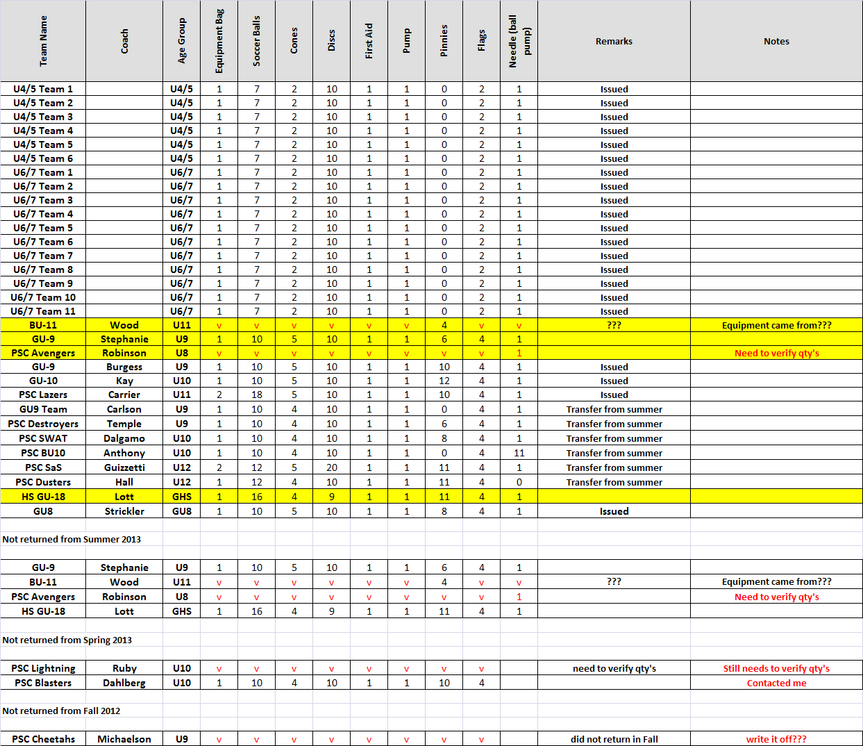

**YELM PSC JAMBOREE DISCUSSION TABLE**

