Revised-January 29th 2026

CAMPBELL COUNTY DEPARTMENT OF RECREATION
YOUTH BASKETBALL LEAGUE
2024-2025

ARTICLE I - Name

The name of this organization shall be Campbell County Department of Recreation Youth Basketball.

ARTICLE II - Objective
The objective of the organization shall be to promote and encourage the youth of Campbell County to participate in the sport of Basketball.

ARTICLE III - Rules

SECTION I - The official rules will be the Constitution and By-laws of the Campbell County Department of Recreation governing Youth Athletics.
SECTION II - The Campbell County Department of Recreation Youth Basketball League will use the Virginia High School League rules governing the game with those exceptions that follow.
ARTICLE IV - Provided by the Recreation Department

SECTION I - Playing and practice sites, site supervisors, scheduling of the games, and officials.
SECTION II - Schedules will be emailed by the Recreation Department and will be given to each coach to communicate with each member of the team. Schedules will be released at least one week before the start of season.
SECTION III - Equipment - balls both game and practice, gym time for both games and practices, Jerseys for each team member will also be provided. Trophies and team pictures will also be provided.

ARTICLE V - Provided by Participant

SECTION I - Participants may be asked to provide or buy team shorts and socks to complete the uniform.
SECTION II - Participants must also provide shoes, and personal protective gear that is appropriate to the sport.

ARTICLE VI - Eligibility

SECTION I - All players should reside in the boundaries of Campbell County, Forest, or Lynchburg City in order to participate in the CCYBL.
SECTION II - The players will be from age 5 to 18 years. Home schooled players will be from 5 to 18 years.
SECTION III - October 1 of the current year will be the date which is used to place participants in the appropriate age bracket.
SECTION IV - Players should be in high school, middle school or elementary school to be eligible to participate in the CCYBL.
SECTION V - Exceptions to this article must be approved by the Recreation department depending on individual situation.

ARTICLE VII - Age Brackets

SECTION I - Players should not have reached their birthday prior to the above mentioned October 1 date in order to participate in the CCYBL.
SECTION II - The age brackets will be as follows:
Ages - 5 and 6 years. Ages - 11 and 12 years.
Ages - 7 and 8 years. Ages - 13 and 14 years.
Ages - 9 and 10 years. Ages - 15 to 18 years.
SECTION III - The brackets may also be divided into boys and girls where available. However, a girl may play in the boys division if they wish but it is not considered Co-Ed.

ARTICLE VIII - DIVISIONS

SECTION I - The CCYBL shall be divided into divisions when possible.
SECTION II - The divisions shall correspond to the areas of the county. The divisions shall be as follows: Altavista, Brookville, Brookneal, Concord, and Rustburg.

ARTICLE IX - Selection of players

SECTION I - In the event that enough players sign up to have more than one team within age brackets and divisions, the Youth Programmer with the coaches will hold a draft in which players are selected by the coaches.
SECTION II - Draft Regulations
- The coaches will have the opportunity to observe the players skills at an open practice session.
- Each player will be given a number to aid the Coaches in making their selections.
- Coaches will select players by number (not name) after the players have left.
- The Youth Programmers will confirm all team players prior to announcements of teams.
- Players not at the draft will be placed on teams at random, by the youth programmers.
- Announcements of teams will be held within 7 days after the Draft is done.
- Head Coaches will automatically have their son(s), daughter(s), and/or family member that’s needs accommodations placed on their team. Head coaches may choose an assistant coach and they will also have their son(s) and or daughter(s) placed on the team.
- Each team will get a first round draft choice then beginning with the second round, teams will forfeit their draft picks until all teams have the same amount of players.
- Drafts will be conducted via a snake draft format. (i.e. 1, 2, 3- 3, 2, 1)
- A Coach’s child will be selected starting with the 4th round pick and continue till all coach’s children are picked for that team.

SECTION III - The Recreation department will maintain team records including pick selections for draft purposes.

ARTICLE X - Team rules
SECTION I - Starting the game
- Coaches are to fill in the official score book with each player’s name whether they are in attendance or not. It is the coach’s responsibility to make sure this is done prior to the start of the game.
- If you have a player who does not attend, please have the scorekeepers make a note of this in the book.
- Players must wear their athletic organization’s issued jersey or penny to participate in games. Street clothes, hoodies (over the jersey), and other clothing are not permitted. Exceptions can be made by League Managers.

SECTION II - Participation requirements
- This section applies to all age groups.
- All players are required to play a minimum of twelve (12) minutes per game.
- A. Players are required to play three (3) minutes per quarter.
  - B. IT IS THE COACH’S RESPONSIBILITY TO MAKE SURE ALL PLAYERS PLAY THEIR REQUIRED TIME! Coach’s not playing all their children the required time will forfeit the game and repeated offenses will result in dismissal as coach. Player substitutions will be made during a dead ball, or a time out must be called.
  - C. Coach’s get two (2) times outs per half, that do not carry over.
  - D. If a game is tied at the end of regulation, a three (3) minute overtime will be played.
    - Teams will have (1) time out in overtime. Time outs will NOT carry over from the second half to overtime. If a game is tied at the end of the first overtime no additional overtime will be played unless the game is a part of the playoff bracket.

SECTION III – 5 & 6 year old rules
- Teams shall preferably consist of a maximum of 10 players and a minimum of 5 players.
- Teams are Co-Ed in nature. Standings will not be kept.
- Scores will not be kept.
- The ball size shall be a junior size or a CB5
- The games will be played on 8ft. goals.
- Court size will preferably be regulation. With the following modification: foul shots are to be taken from the second set of paint dashes from the shooter aligning the shooter roughly 2 meters closer.
- There will be no full court press in this age group. Players may play defense within the three-point line. Defenders are not allowed to come outside of the three-point line until the ball has entered that area.
- Games will be held first on Saturday’s. The coaches will serve as referees and are allowed on the court to help with the flow of the game.
- Games will consist of 4 quarters, with each quarter being 7 minutes long, Running clock style. Each team will have 2 timeouts per half. Timeouts do not carry over.
- Every Player is required to play at least 3 minutes a quarter.
- There will be no scorekeepers or referees.
- Before the second half begins, both teams will have an opportunity for each player to shoot free throws on their respective goals.

SECTION IV - 7 & 8 year old rules
- Teams shall preferably consist of a maximum of 10 players and a minimum of 5 players.
- Teams are Co-Ed in nature. Standings will not be kept.
- The ball size shall be 27.5
- The games will be played on 9ft. goals.
- Court size will preferably be regulation. With the following modification: Foul shots are to be taken from the first set of paint dashes from the shooter aligning the shooter roughly 1 meter closer.
- There will be no full court press in this age group. You are allowed to half court press in the last minute of the 4th quarter Players must play defense within the tip of the three-point line (see figure 1). Defenders are not allowed to pass outside of the tip of the three-point line until the ball has entered that area.
- A team ahead by 20 points must play defense inside the tip of the three-point arc, once the ball goes into that area the entire half court opens. (See figure 1)
- The game shall consist of 4 quarters of ten (10) minutes each with a four (4) minute half time.
- The clock will only stop during the last 2 minutes of the half and the final quarter. Clock will stop, however, because of injuries and if the referees deem it necessary.
- There will be a short stoppage of the clock in order to get the players set for the foul shot. The officials will handle the setup of the players. The clock will be restarted when the ball is given to the player. Coaches are not allowed to communicate with players at this time. A time out will be charged to the team who is in violation of this rule.
- Free substitutions are allowed throughout the game. The players must be at the table ready to check in and will be buzzed in at the next dead ball. The player needs to know who they are substituting with because the clock will not stop during substitutions. If players are not at the scorer’s table prior to the dead ball, they will be forced to wait until the next dead ball

SECTION V - 9 & 10 years old Boys & Girls Rules
- Teams shall preferably consist of a maximum of 10 players and a minimum of 5 players.
- Standings will not be kept.
- The ball size shall be 28.5.
- Court size will preferably be regulation. With the following modification: 9/10 girls’ foul shots are to be taken from the first set of paint dashes from the shooter aligning the shooter roughly 1 meter closer.
- The last two minutes of the game teams may full court press. Players may play man to man/zone once the ball has crossed the half court line. Once the offensive player with the ball has both feet established in the front court, then defense is allowed to be played.
- A team ahead by 20 points must play defense inside the tip of the three-point arc, once the ball goes into that area the entire half court opens. (See figure 1)
- The game shall consist of 4 quarters of ten (10) minutes each with a four (4) minute half time.
- The clock will only stop during the last 2 minutes of the half and the final quarter. Clock will stop however for injuries if the referees deem it necessary.
- Free substitutions are allowed throughout the game. The players must be at the table ready to check in and will be buzzed in at the next dead ball. The player needs to know who they are substituting with because the clock will not stop during substitutions. If players are not at the scorer’s table prior to the dead ball, they will be forced to wait until the next dead ball.

SECTION VI - 11 & 12 years old Boys & Girls Rules
- Teams shall preferably consist of a maximum of 10 players and a minimum of 5 players.
- Teams can be Co-Ed in nature. Standings will not be kept.
- The ball size shall be a regulation 29.5 size for the boys. 28.5 for Girls
- Court size will preferably be regulation.
- There will be no court restrictions as to the press in this age group. However, the team that is ahead by 20 points will not be allowed to press at all. A team ahead by 20 points must play defense inside the tip of the three-point arc, once the ball goes into that area the entire half court opens. (See figure 1)
- The game shall consist of 4 quarters of ten (10) minutes each with four (4) minute half time.
- The clock will only stop during the last 2 minutes of the half and the final quarter. Clocks will stop however for injuries and if the referees deem it necessary.
- Free substitutions are allowed throughout the game. The players must be at the table ready to check in and will be buzzed in at the next dead ball. The player needs to know who they are substituting with because the clock will not stop during substitutions. If players are not at the scorer’s table prior to the dead ball, they will be forced to wait until the next dead ball.

SECTION VII – 13 -15 years old Boys & Girls Rules
- Teams shall preferably consist of a maximum of 10 players and a minimum of 5 players.
- Teams can be Co-Ed in nature. Standings will not be kept.
- The ball size shall be a regulation 29.5 size for the boys. 28.5 for Girls
- Court size will preferably be regulation.
- There will be no court restrictions as to the press in this age group. However, the team that is ahead by 20 points will not be allowed to press at all. A team ahead by 20 points must play defense inside the tip of the three-point arc, once the ball goes into that area the entire half court opens. (See figure 1)
- The game shall consist of 4 quarters of ten (10) minutes each with four (4) minute half time.
- The clock will only stop during the last 2 minutes of the half and the final quarter. Clocks will stop however for injuries and if the referees deem it necessary.
- Free substitutions are allowed throughout the game. The players must be at the table ready to check in and will be buzzed in at the next dead ball. The player needs to know who they are substituting with because the clock will not stop during substitutions. If players are not at the scorer’s table prior to the dead ball, they will be forced to wait until the next dead ball.

SECTION VIII – Post Season Tournament
      - The post season Tournament will be for all ages 9-10 and up. 5-6 and 7-8 will continue to be primarily educationally based.
      - The Post season will begin in Week 5/6/7 depending on league size with the first round of games. In the following weeks the teams that won in the previous week will continue through the bracket and play against each other. The losing teams from the previous week will play each other. The teams that win week 8 will play each other the next day (Sunday) for the championship for their respective age groups.
      - Tournament brackets will be randomly selected, and teams will be informed of the tournament bracket in week 5.
      - We reserve the right to amend the tournament schedule and the tournament bracket

ARTICLE XII - AMENDMENTS & EXCEPTIONS

SECTION I – Refund and injury rules

1. If a player is injured prior to the completion of the fourth game that will rule them out for the remainder for the season they may receive a full refund. Medical documentation may be required in some cases.
2. If a player is suspended for the remainder of the season at any point a refund will NOT be given.

SECTION II- Disciplinary Rulings
- If there is a need to discipline a player, coaches are to inform the Site Supervisor/program supervisor and the league director in writing or email for action to being taken. If disciplinary action is needed the recreation department will impose said action.
- If a coach or player knowingly allows another non-registered player to play in a game, they will be suspended for the remainder of that season.
- If any parent, guardian, player, coach, or referee engages in disrespectful or vulgar verbal confrontation with another person, that person will be subject to a minimum of a one game suspension. We reserve the right to increase the punishment depending on the severity of the act.
- If any parent, guardian, player, coach, or referee engages in a physical altercation with another person, that person will be subject to a minimum of a one game suspension. We reserve the right to increase the punishment depending on the severity of the act.
- Parents are not permitted to step on the court at any point during the live game. If a parent enters the court during play, they will be asked to leave the facility till the end of the game. We reserve the right to increase the punishment depending on the severity of the act.
- Only staff, players, and coaches are allowed in the benches/score table area. If a patron not in one of those categories comes over to the sideline, you will be asked to leave the facility and could face a suspension from Campbell County Parks and Rec events. If a player is injured or there is an emergency, a parent or guardian is permitted in the benches area. For emergencies, please contact staff or a site manager.
- If a player or coach is caught cheating before, during, or post-game they will be suspended for the remainder of that season. We reserve the right to increase the punishment depending on the severity of the act.
- If a coach receives a technical foul they are required to stay seated during play for the remainder of the game.
- Second Tech for any coach they must leave the facility.

ARTICLE XII - AMENDMENTS & EXCEPTIONS

SECTION I - Exceptions can be made prior to the start of the playing season if there are circumstances which warrant exceptions being made.
SECTION II - Amendments can be made prior to the start of the playing season provided they are in accordance with the Bylaws of the Campbell County Youth Athletics. These must be presented in writing to the Athletic Director of the Recreation Department for consideration.
ARTICLE XIII – FIGURES

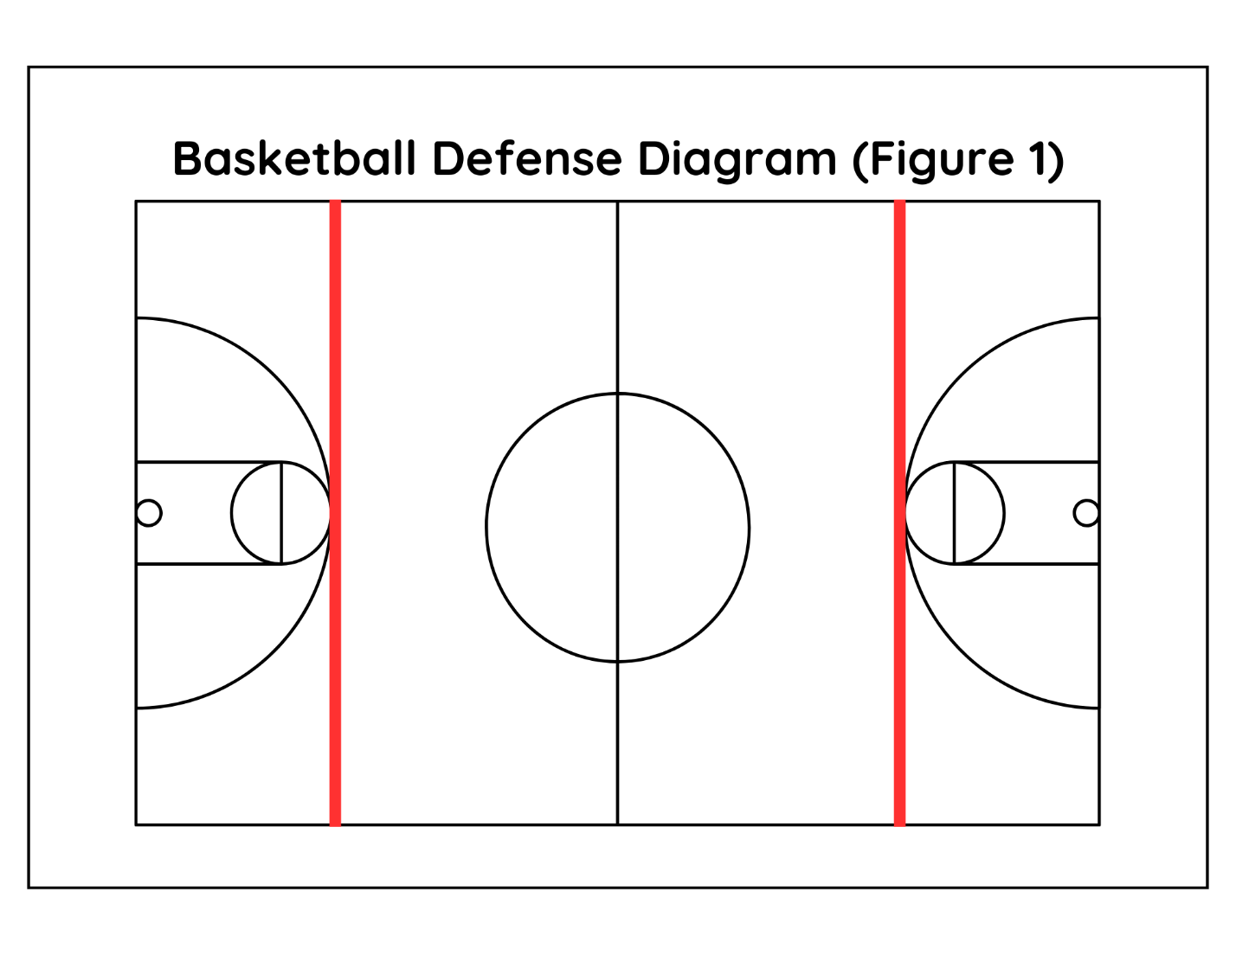
Figure 1: Defense must be played within the marked lines under certain game situations (see your age group for rule clarification). If defense is played outside of these lines, then referees will call a foul and possession will return to the offensive team, in an in-bound situation.

