Registering for Interclub Races (2025-25)
Registering for races.
The official and most current location for the race schedule is on the Tri-State Alpine Ski Racing Association site. https://tristateskiracicng.org Schedule – Interclub The races are also in the TeamSL team calendars.
The interclub races are split up among the different mountains in order to manage the size of the field. Look for races with Catamount (CAT) on the right. You cannot go to the other IC races.
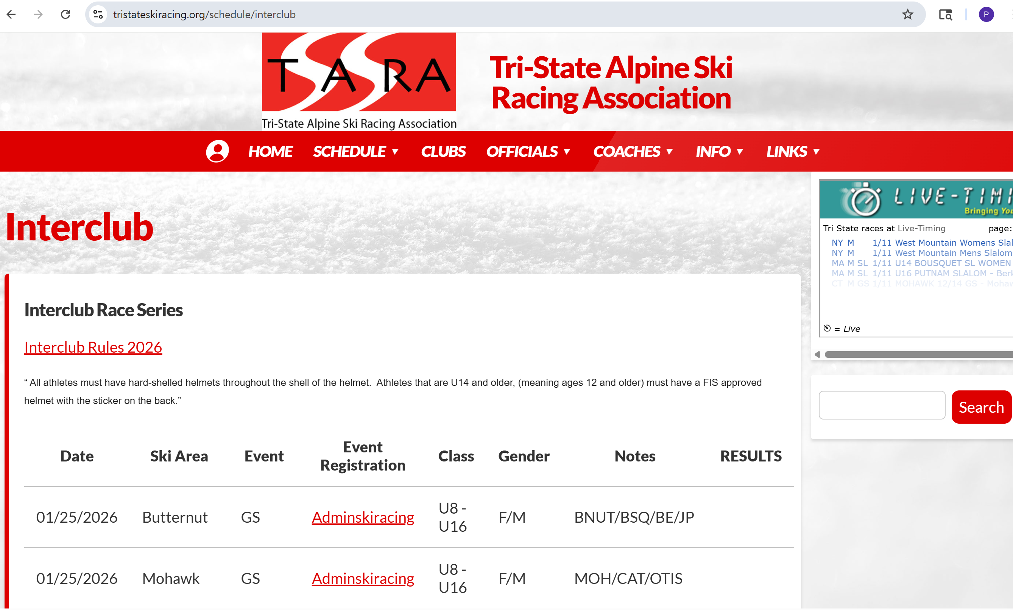

Registration must be made in the Adminskiracing site where you need to first set up an account and register your racer. There is a link on the TSASSRA site. Before Registering for a race, the racer must also be registered in USSA and current.
http://adminskiracing.com
Once you have an account in the system you can find races.
Unfortunately, under My Events on AdminSki it shows Races “you are eligible for” which is NOT CORRECT. This is due to Admin Ski Racings inability to separate the groups in Tri-State
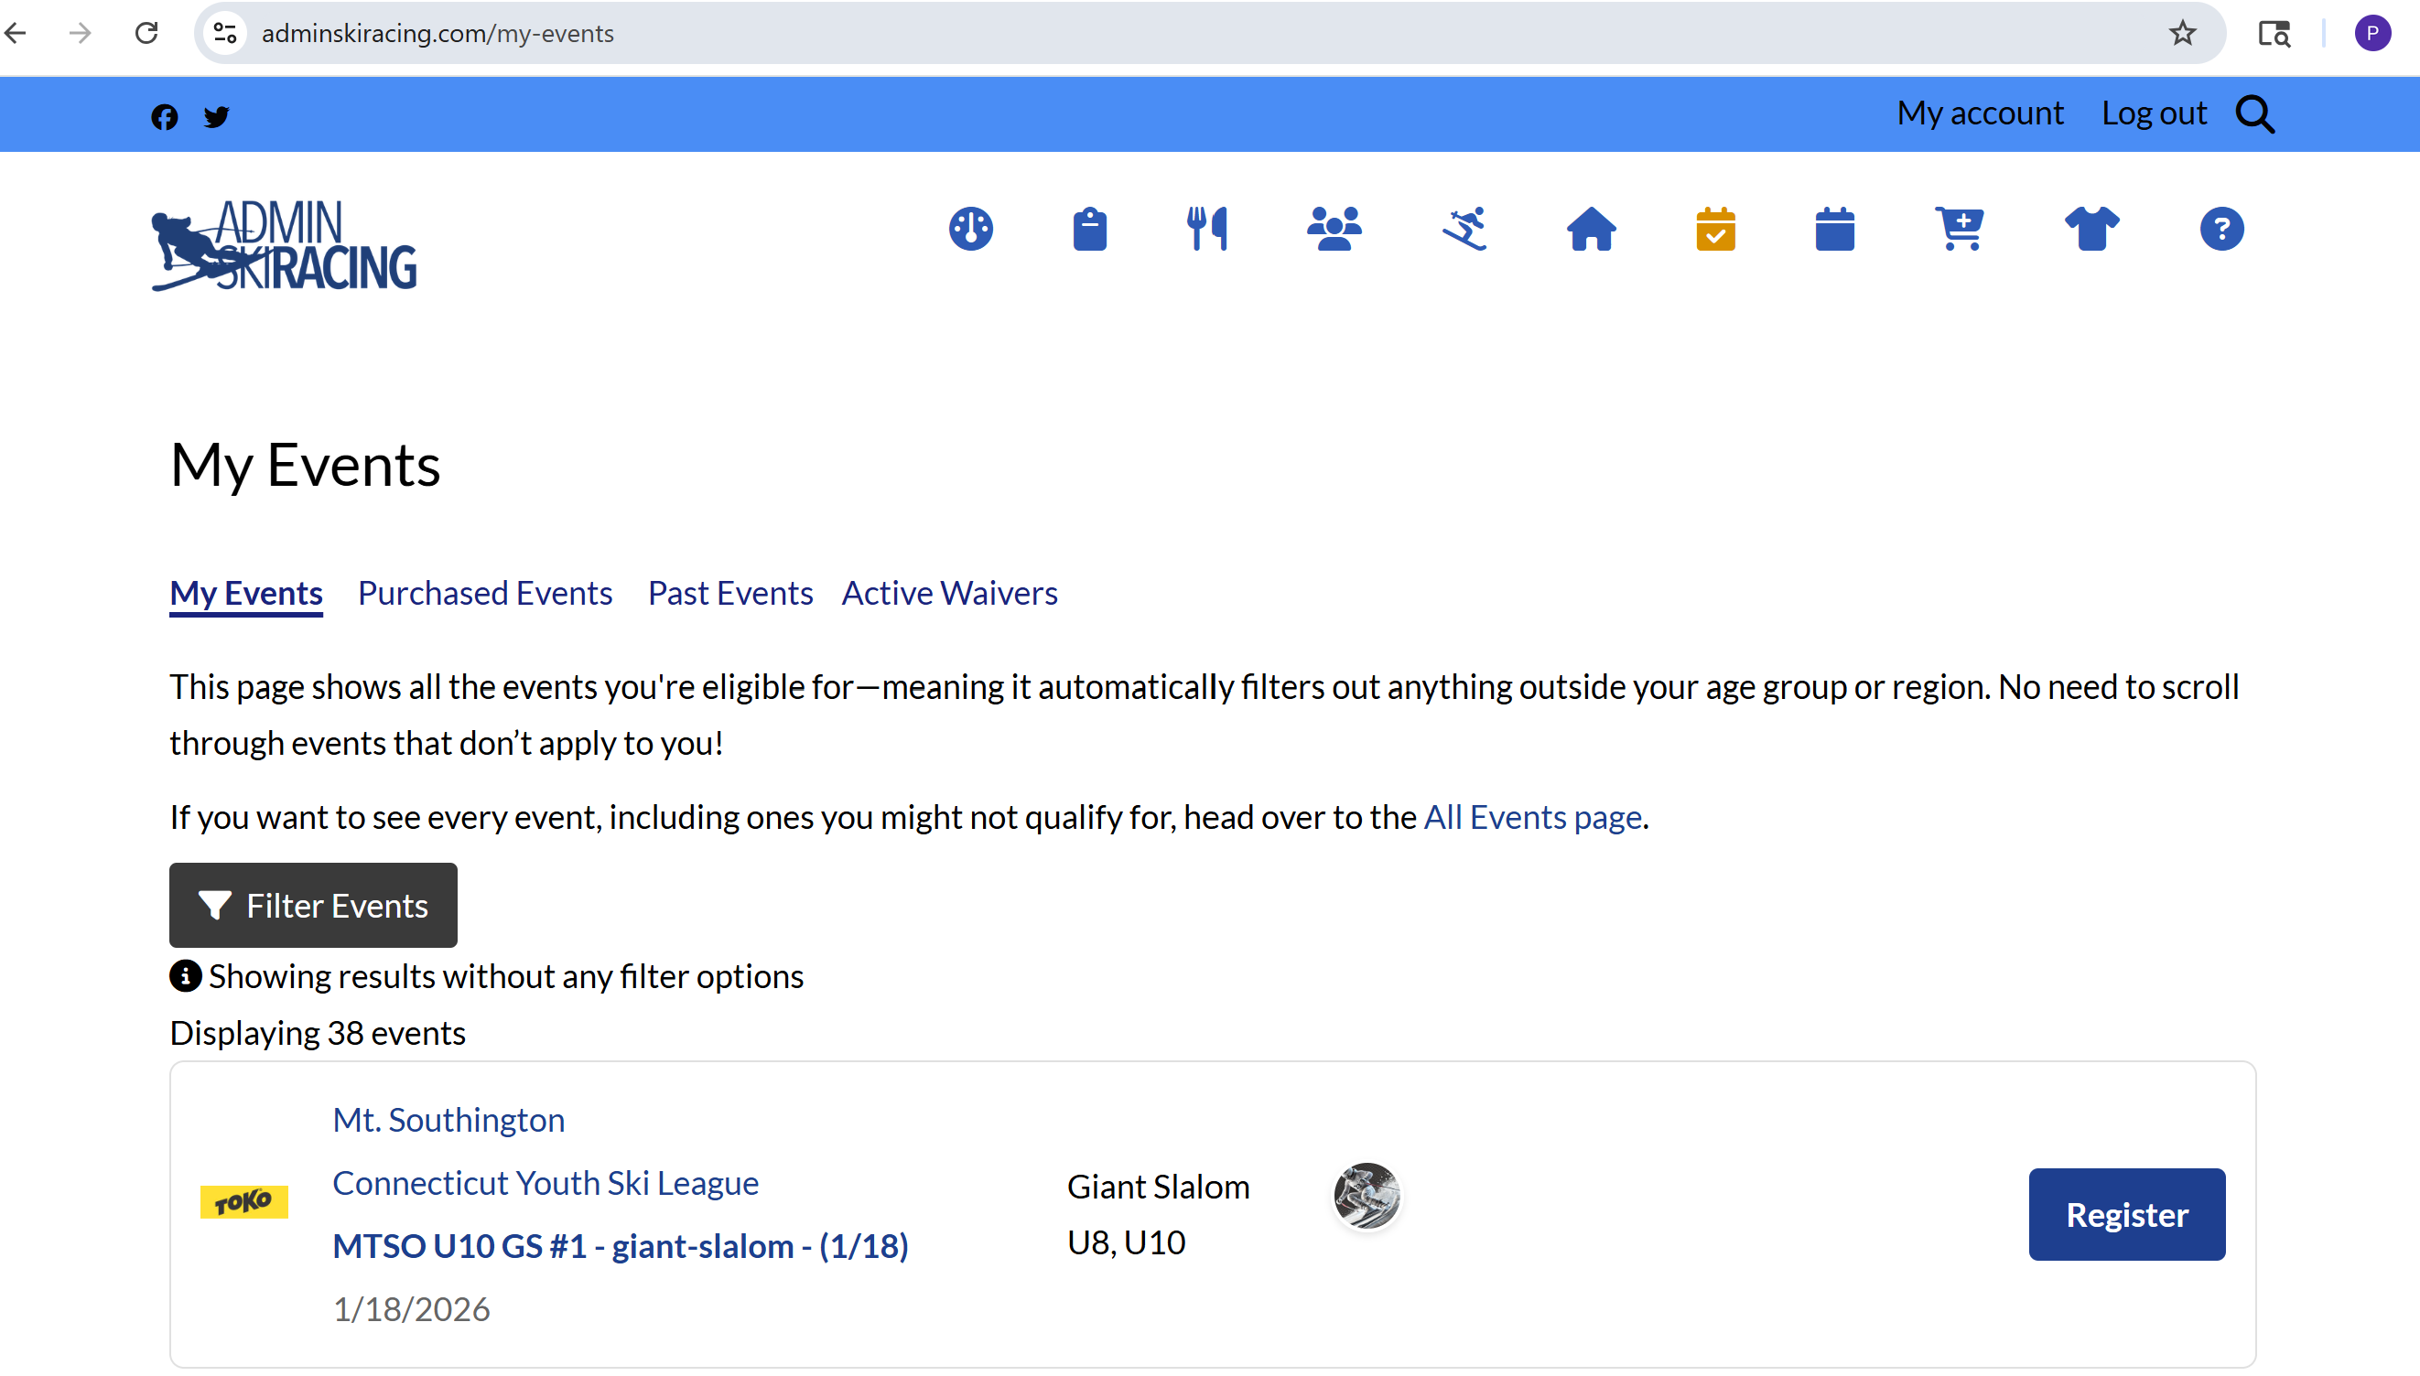
Scroll down and find the IC Event.

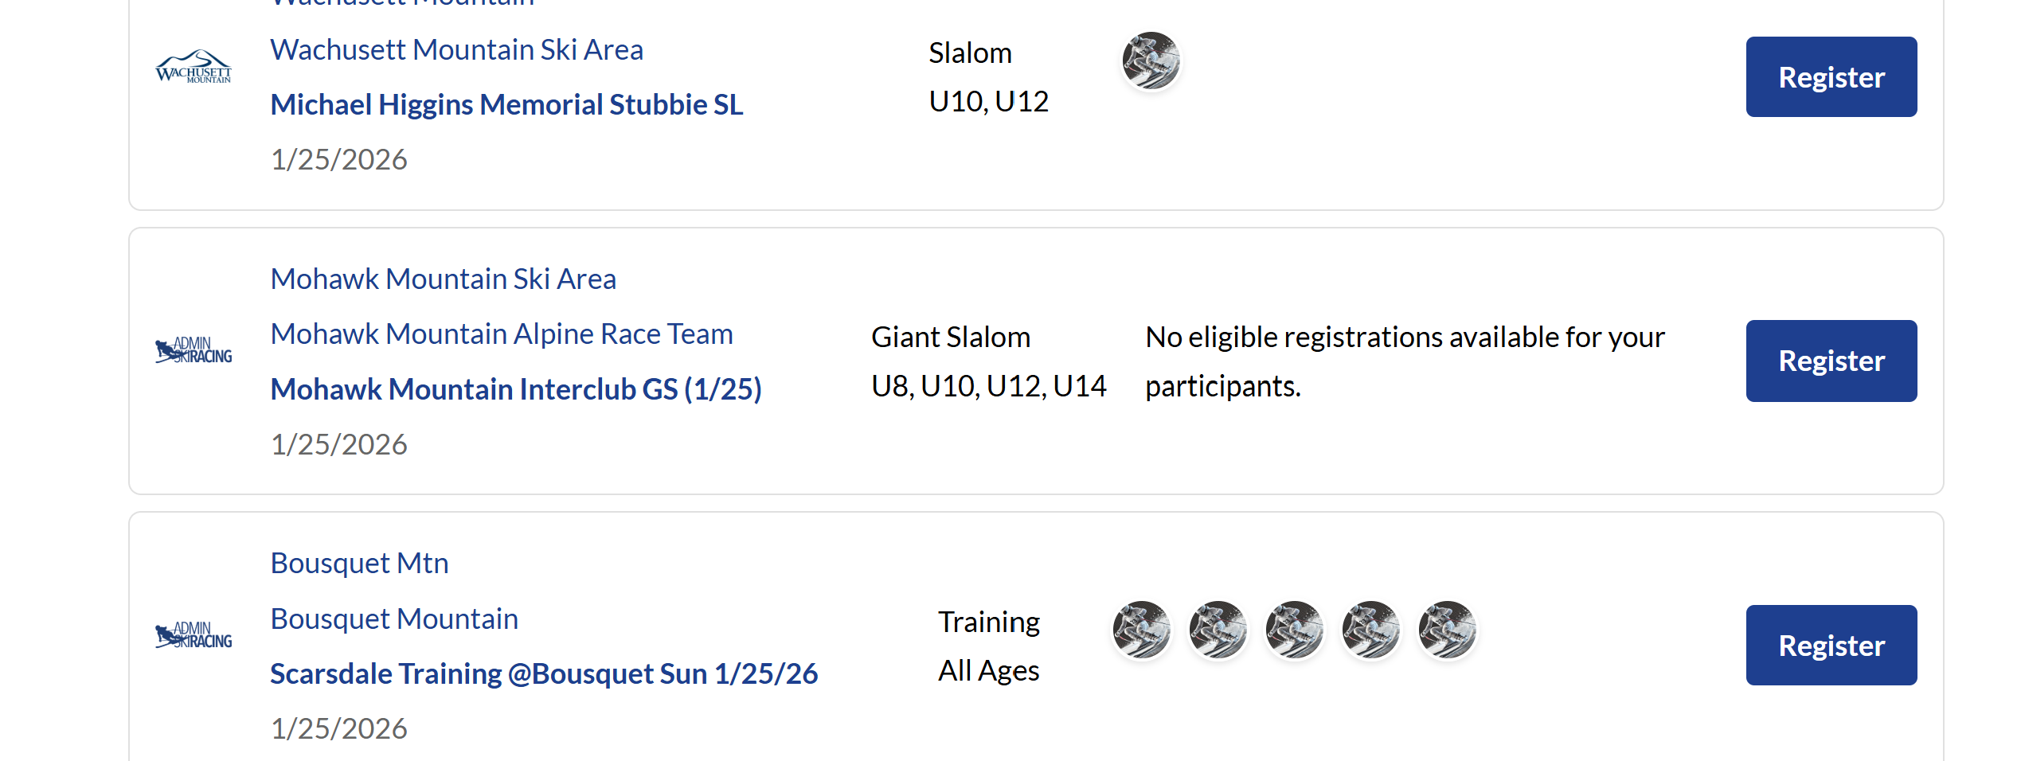

By “clicking” on the event you can get details and see who is registered.
You can also use the filter function on my events or all events to find TriState events.
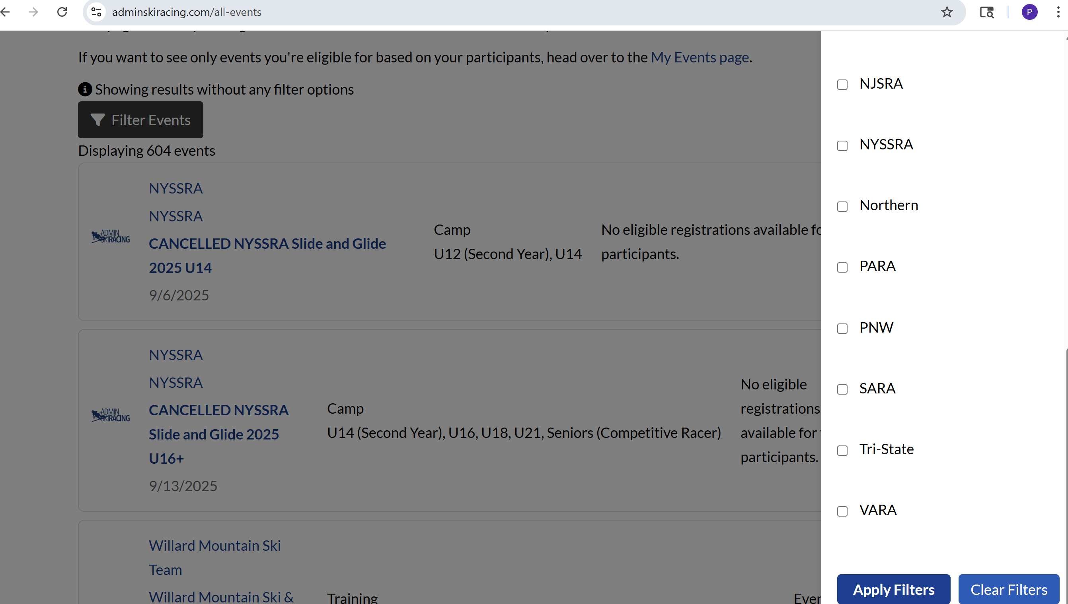

Warnings
Interclub racers are in the Tristate region of USSA. Catamount’s “Tri-State” program is for racers participating in TS post season event qualifier series. Interclub Racers that are U12 or U14 may show up as eligible for a “Tri-State” race, but this is due to Admin Ski Racings inability to separate the groups in Tri-State. This may also happen with CYSL races. Other Interclub races which Catamount is NOT participating in also show up.

