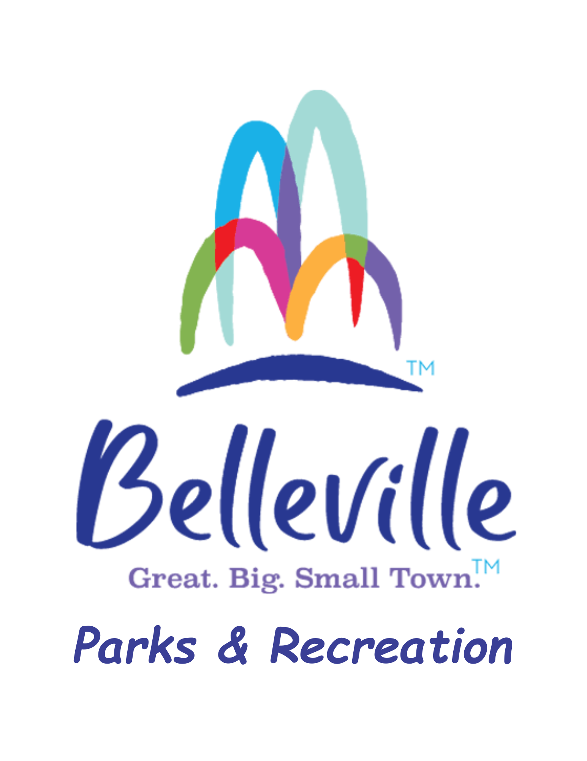

BELLEVILLE PARKS AND RECREATION

Release, Waiver, Discharge and Covenant Not to Sue

Description of Activity (include property location):____________________________________________

_____________________________________________________________________________________

Date(s) of Activity:_____________________________________________________________________

In connection with my participation in the above-referenced Activity at the City of Belleville, Illinois (hereinafter referred to as “City”), the undersigned hereby certifies as follows:

1. This is a legally binding Release, Waiver, Discharge and Covenant Not to Sue (hereinafter collectively referred to as “Release”), made voluntarily by me, the undersigned Releasor, on my own behalf, and on behalf of my heirs, executors, administrators, legal representatives and assigns (hereinafter collectively referred to as “Releasor”, “I” or “me”, which terms shall also include Releasor’s parents or guardian, if Releasor is under 18 years of age).

2. I fully recognize that there are dangers and risks to which I may be exposed by participating in the activity described above (hereinafter referred to as the “Activity”). These risks may include, but are not limited to, personal injury or death, and property damage or loss.

3. I have carefully identified, reviewed and considered the risks of the Activity and incorporated this information into my decision to participate in the Activity. I agree to abide by any applicable rules and regulations associated with the Activity, copies of which are attached hereto.

4. I understand that City does not require me and has not encouraged me to participate in this Activity, but I want to do so despite the possible dangers and risks and the requirement that I sign this Release.

5. I affirm that I have consulted with a medical doctor with regard to my personal medical needs and that there are no health-related issues which preclude or restrict my participation in the Activity. I affirm that I have adequate medical or health insurance to cover any medical assistance that I may require.

6. With informed consent and in consideration of permission to participate in the in the Activity, I hereby release, waive, discharge and covenant not to sue City, its elected officials, officers, servants, agents and employees, as well as any person and/or entity associated with this Activity that required release and/or indemnification by City (hereinafter referred to as (“Releasees”)) from any and all liability claims, demands actions and causes of action whatsoever arising out of or relating to any loss, damage or injury, including death, that may be sustained by me, or to any property belonging to me, while participating in the Activity, I voluntarily assume full responsibility for any risks of loss, property damage or personal injury, including death, that may be sustained by me, or any loss or damage to property owned by me, as a result of my participation in the Activity, and I further hereby agree to indemnify and save and hold harmless the Releasees and each of them, from any loss liability, damage or costs they may incur during my participation in the Activity. It is my express intent that this Release shall bind the members of my family and spouse, if I am alive, and my heirs, assignees and personal representative, if I am deceased, and shall be deemed as a Release, Waiver, Discharge and Covenant Not to Sue the above named Releasees.

7. I agree that this Release shall be governed for all purposes by Illinois law. Notwithstanding anything herein to the contrary, I understand that all terms and conditions of this Release shall be construed or interpreted as consistent with, and not as a waiver, express or implied, of any of the immunities, rights, benefits, protection, or other provisions of the Illinois Local Governmental and Governmental Employees Tort Immunity Act (745 ILCS 10/1 et seq.) as now or hereafter amended.

8. I agree that should any provision of this Release be found to be unenforceable, that all remaining provisions of this Release will remain in full force and effect.

9. I agree that any dispute and/or legal action arising out of this Release and/or concerning my participation in the Activity must be resolved by binding arbitration through the American Arbitration Association in Belleville, Illinois. In the event of such arbitration, each party shall bear its own costs, including attorney’s fees, except that I agree to fully indemnify City, for all of its costs (including attorney’s fees) if I commence an action or claim against City, upon claims I have previously released or waived under this Release.

10. I have read and fully understand this entire Release, I acknowledge that I have had the opportunity to review this Release with an attorney of my choosing if I so desire, and I agree to be legally bound by this Release.

11. I hereby grant City permission to use my likeness and that of my minor child/ward in a photo, video, or other media in any and all its publications without payment or other consideration.

_______________________________________________________
Participant’s Printed Name

_______________________________________________________ __________________________
Participant’s Signature, unless 18 years and younger Date

Parent/Guardian Signature required if Participant is under 18 years of age.

_______________________________________________________
Parent/Guardian Printed Name

_______________________________________________________ __________________________
Parent/Guardian Signature Date

PARTICIPATION WILL BE DENIED
If this signature of adult participation or parent/guardian and date are not on this waiver.

