How to use Teamsideline
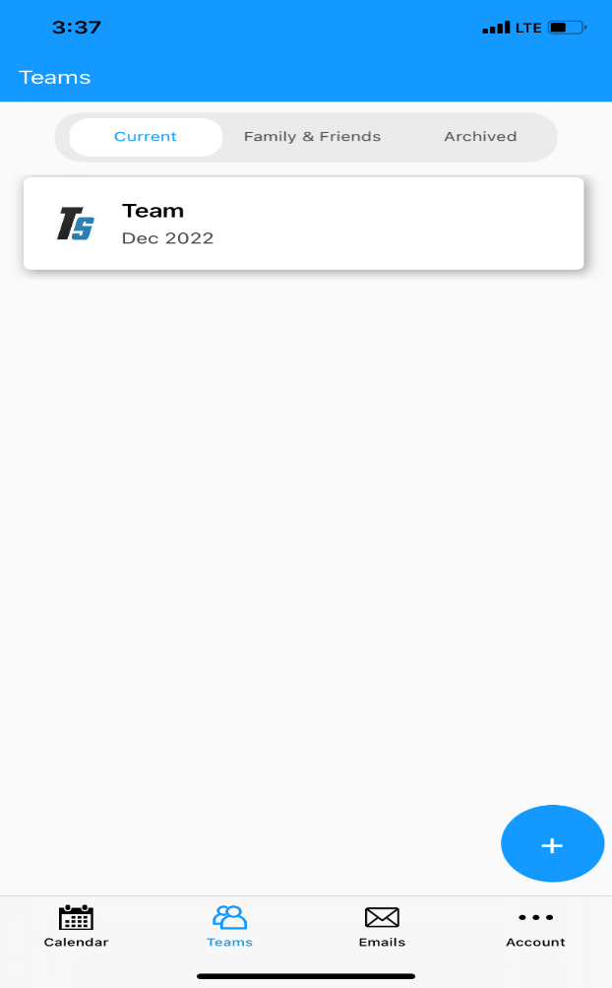
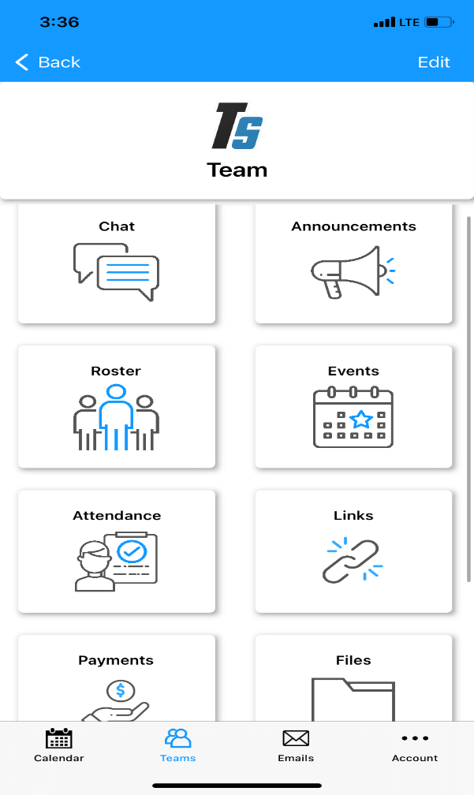
All your options on this page.

Click your team!

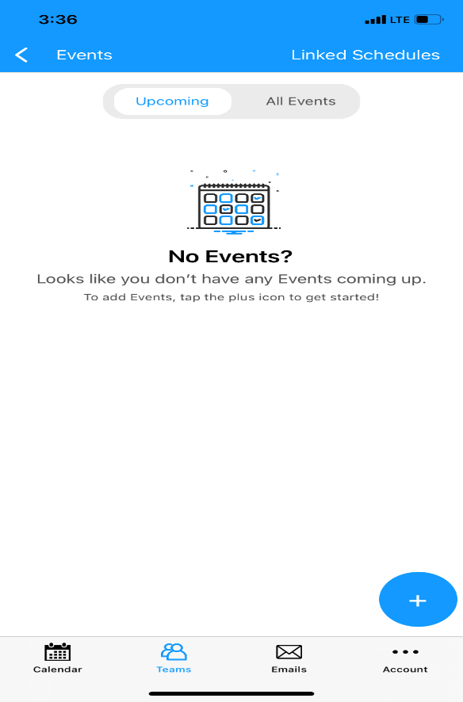
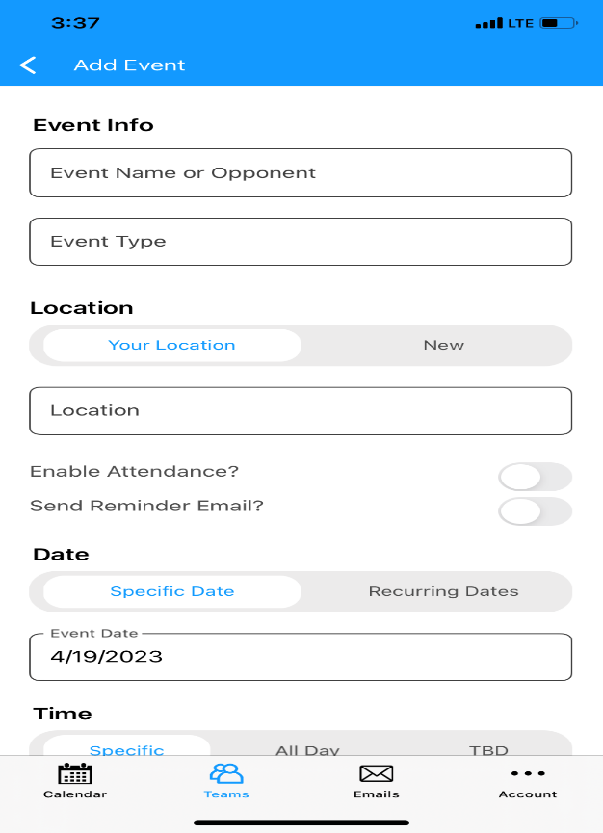
Follow steps to put your practices

After clicking the calendar, you will get this, or see your game schedule. Click the plus sign down at the bottom to add practices

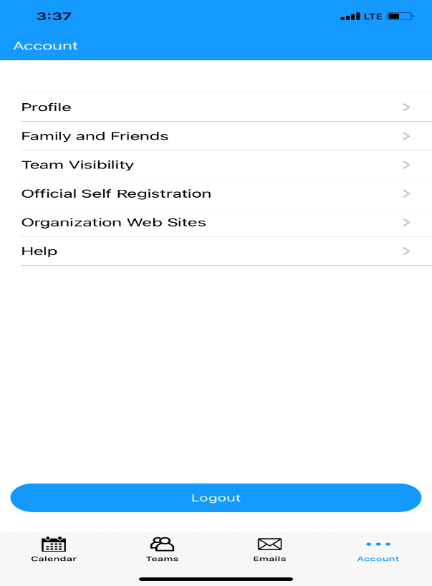
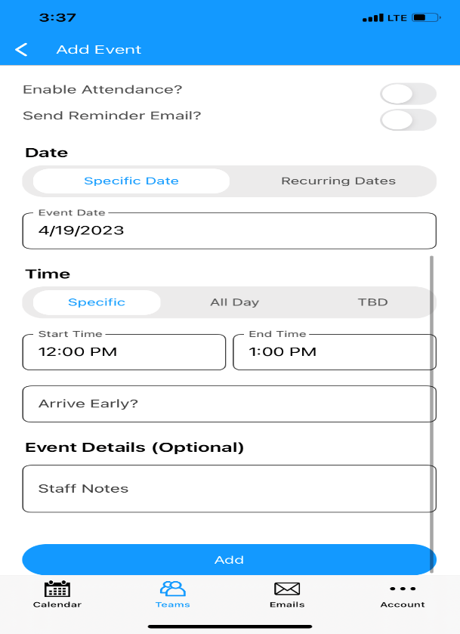

Once you go to account you can update your profile

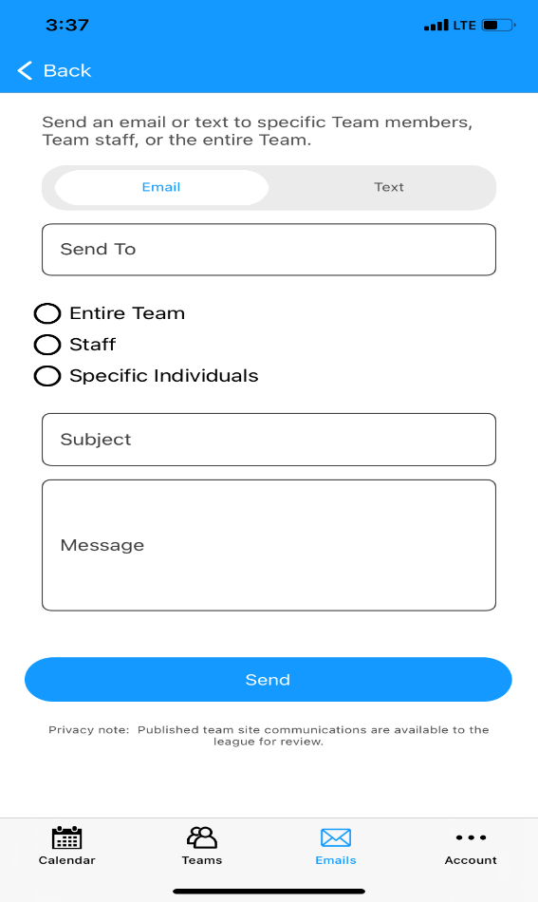
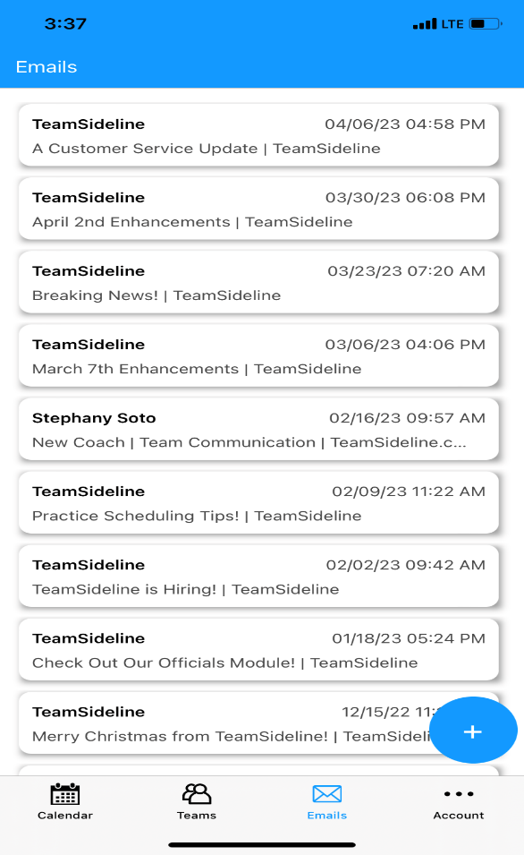

On the email tab, after you press the plus sign you can compose an email or text
Your team can email on this app, or our emails will show on here, and you can send emails to your team

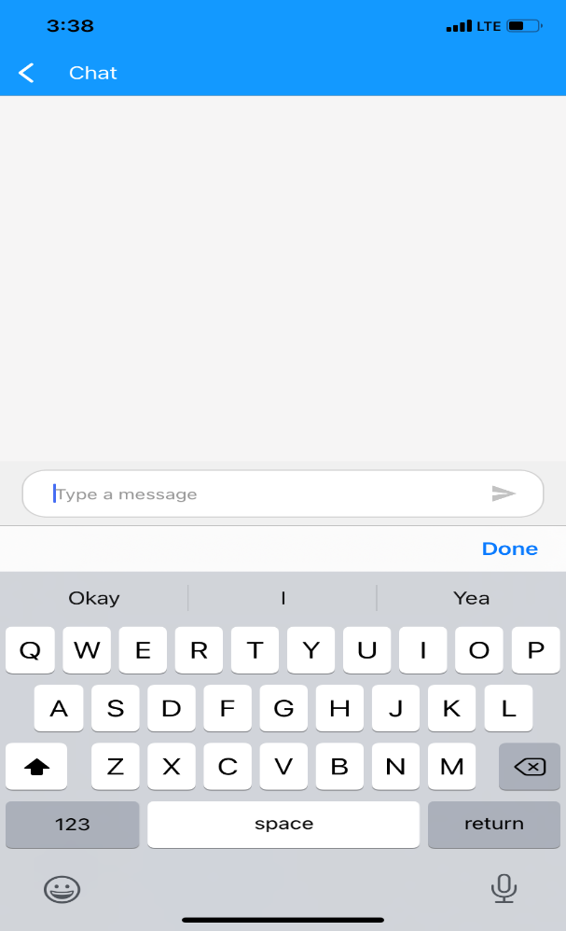

Off of the main menu page you can utilize the chat feature for your whole team.

