2026

YOUTH BASKETBALL PROGRAM

RULES AND REGULATIONS

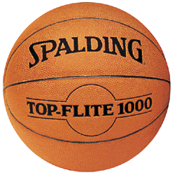

CITY OF HOUSTON

PARKS AND RECREATION DEPARTMENT

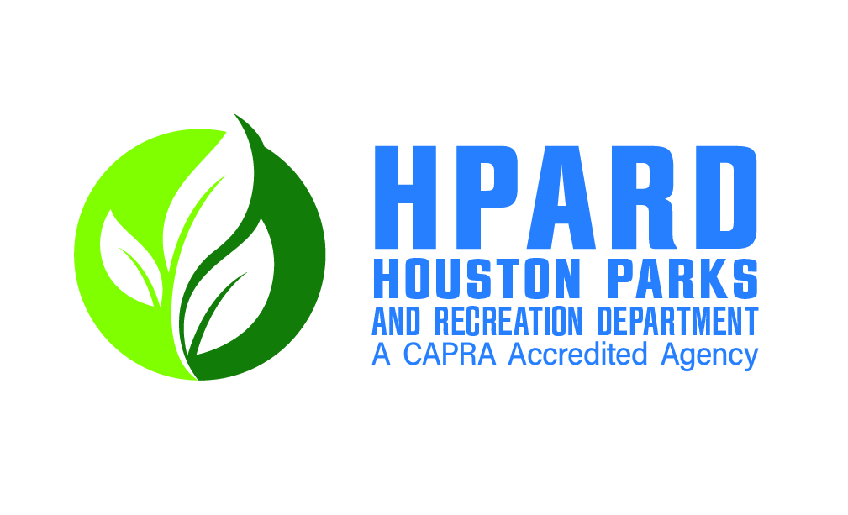

January 5, 2026

Dear Team Manager,

On behalf of the Houston Parks and Recreation Department, I would like to welcome you as a participant in our 2026 Youth Basketball Program.

Our goal is to offer quality sports programming at affordable prices and see that each participant has an enjoyable leisure experience.

Please read the rulebook at your first opportunity to familiarize yourself with our league’s rules and regulations.

We now have an online registration system. You can establish your online account athttps://apm.activecommunities.com/houstonparks/Home, but you will not be able to register for a league until the specified registration dates for a specific season. The online registration system was approved by the Mayor and City Council in 2009.

You can also visit our department’s web site at www.houstonparks.org for additional information as well.

We now have an HPARD Facebook Page and Twitter Page. We will add updates on league registrations and tournaments throughout the year.

Again, welcome to our program. Wishing your team a successful and enjoyable season.

Sincerely,

Sean Gay, Senior Superintendent
Recreation and Wellness Division

A. 2026 LEAGUE DATES

2026 Winter Season
League Dates: January 5 – March 6, 2026
Online Registration Dates: December 15, 2025 – January 17, 2026

B. LENGTH OF SCHEDULE

Leagues will consist of an eight (4) week single season schedule plus one (1) tournament.

Registrations are accepted on a “first come, first serve” basis.

G. ROSTER LIMIT

Maximum roster limits will be twelve (25) players.

H. ROSTER CHANGES

No roster changes.

I. SCHEDULES

Schedules are posted one week prior to the season’s start date on the Adult Sports Team Sideline website and app: Go to: https://www.teamsideline.com/sites/houstonparks/home

J. LENGTH OF PLAYING TIME

All games will be played in twenty (13) minute running halves. Clock will stop for all timeouts throughout the game; clock will stop for all violations and time outs that occur during the last two (2) minutes of each half.

K. OVERTIME PERIODS

If the score is tied at the end of the second half, play will continue without change of baskets for one or more extra periods with a one-minute intermission before each extra period. Length of each extra period will be three (2) minutes.

L. FORFEIT GAMES

There will be a 5-minute grace period for each game.

Any team not ready to play at game time shall forfeit. Teams will notify all concerned by reporting to the HPARD staff as much as possible in advance, if they foresee they will be unable to field a team for scheduled play. HPARD staff will then contact the other team and possibly save unnecessary travel time. Officials do not have to work forfeited games.

M. PLAYING RULES

All games will be played under NCAA rules and regulations, unless otherwise stated. All players must wear same colored jersey’s numbered front and back or the team will be subject to a forfeit.

O. PARTICIPANT BEHAVIOR

Coaches are reminded that they are responsible for the behavior of their players and fans before, during and after all games. Conduct of participants deemed detrimental to the program will result in such person or persons being suspended from participation in the basketball program for a period of time as necessary due to the severity of the infraction. Officials are authorized to control the behavior of participants in the program from the time of arrival at the court until leaving community center premises. If you or anyone on your team has a problem with an official, do not approach the official; simply call the Adult Sports Office at (832) 395-7130 the next day, and we will monitor the situation to make changes, if necessary. FIGHTING WILL NOT BE TOLERATED. All persons involved in fighting will automatically be suspended for a period of time to be determined by the severity of the fight.

Any player banished from the game by the officials will also be ineligible to participate in the next game. The player may remain on his team’s bench, but may not direct any remarks towards the official or opposition during the remainder of the game. If a player is asked to leave the park/community center, he shall be suspended for the remainder of the season. If a player does not comply, the team may be forced to forfeit the game and possibly be removed from the league without refund. If a player who was banished from a future game is found playing in that game, the team shall automatically forfeit the game. Officials shall report any actions of players banished from their game to an Adult Sports staff by the next business day.

P. GYMNASIUM RULES

- No smoking in building/community center.
- No eating or drinking in gymnasium.
- No profanity allowed.
- Fighting will not be tolerated.
- Coaches are responsible to the actions of their team players and fans before, during and after the games while on park/community center property.

S. ALCOHOL PROHIBITED

Alcohol in any form is prohibited at all City of Houston Parks and Recreation community centers. Any player seen consuming alcohol before or during a game, will be immediately ejected from the game and suspended from future game(s).

T. GAME SITES:

Fonde Recreation Center Robinson Jr. Community Center
110 Sabine 2020 Herman Dr.
Houston, TX 77007 Houston, TX 77004

Alief Community Center Denver Harbor Multi-Purpose Center
11903 Bellaire 6402 Market Street
Houston, TX 77072 Houston, TX 77020

Emancipation Community Center Tidwell Community Center
3018 Dowling 9720 Spaulding St
Houston, TX 77004 Houston, TX 77016

Marian Community Center Moody Community Center
11101 S. Gessner 3725 Fulton St
Houston, TX 77071 Houston, TX 77009

Melrose Community Center Sunnyside Community Center
1001 Canino Rd 3502 W Bellfort Ave
Houston, TX 77076 Houston, TX 77051

U. CONTACT INFORMATION

- General Information: (832) 395-7130
- Fax Number: (832) 395-9445
- E-mail Address: adult.sports@houstontx.gov
- Web Site Information: www.houstonparks.org
- Online Registration Site: https://apm.activecommunities.com/houstonparks/Home

