The headshot picture specifications are as follows:
- Majority of image, must be from shoulders to the top of the head.
- Athlete's face needs to be clear of any obstructions (NO hats, NO sunglasses, NO mouthguards, NO helmets, NO face paint).
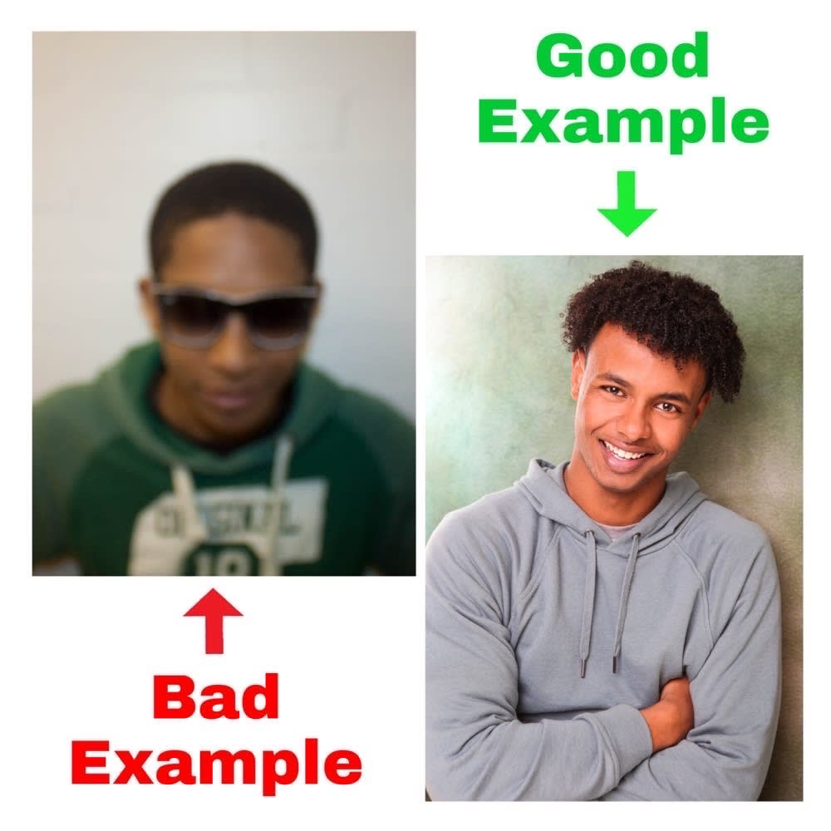

Birth Certificate:
Must be a scanned copy or picture of players state issued birth certificate.
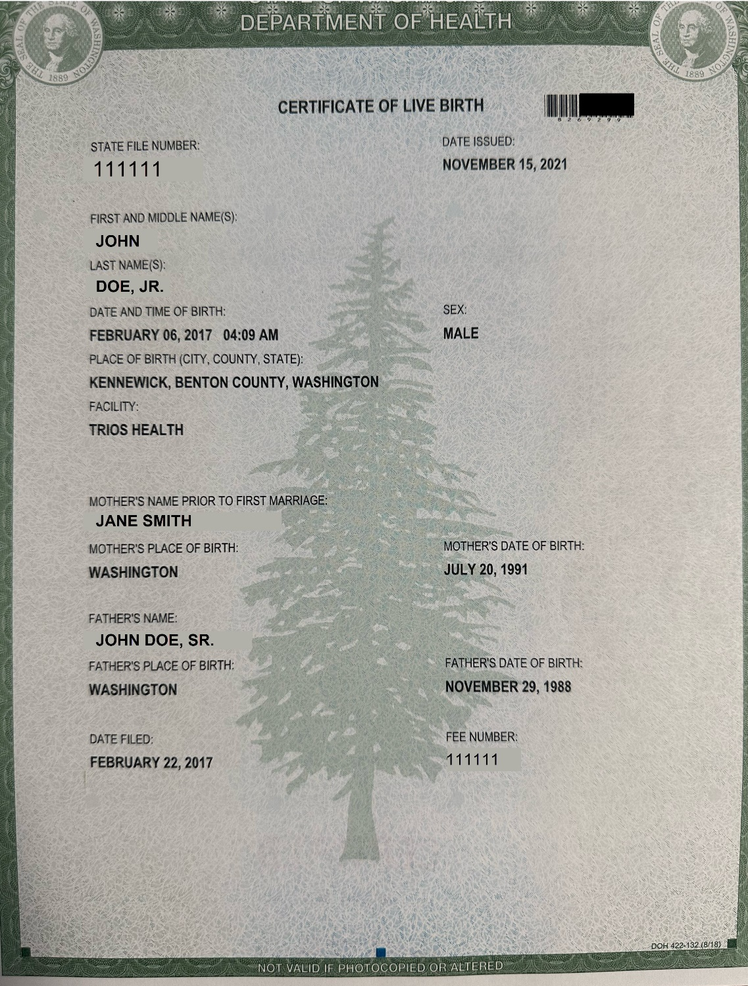
Address Verification (Proof of Address) Upload:
Must be an essential UTILITY BILL (electricity, garbage, water, natural gas), OPENED WITH SERVICE ADDRESS, DATE and contain the Parents/Guardian(s) name.
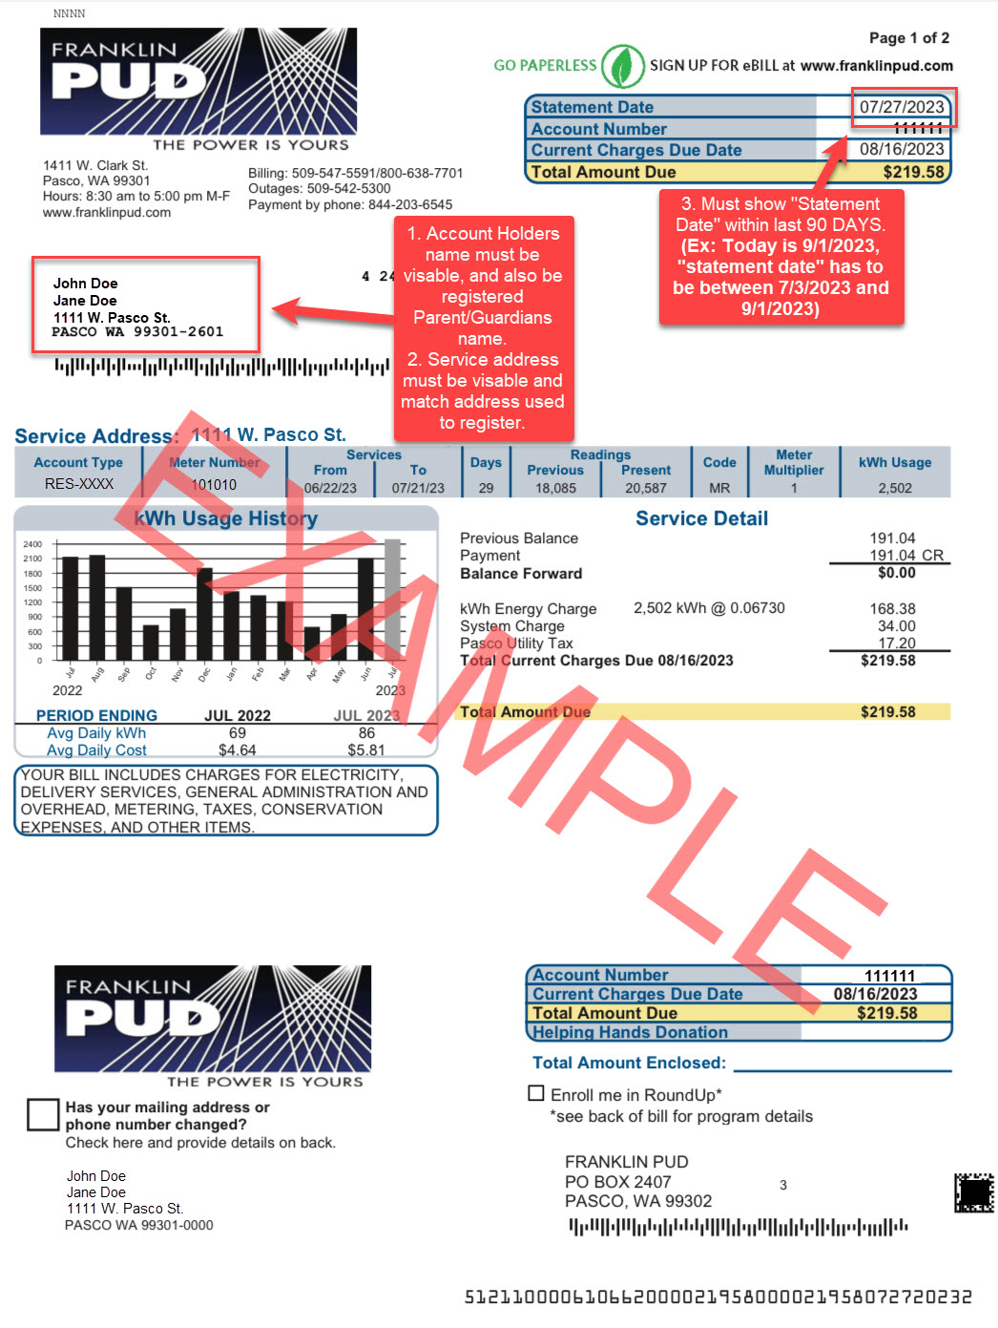
Grade Verification Upload:
Must be a Screenshot from ClassDojo/ParentSquare/Power School, or a photo/copy of a Report Card, School ID, or any school document that has PLAYER’S NAME, GRADE LEVEL, SCHOOL NAME, & SCHOOL YEAR, all visible on the same document.


