How to set up your Team Account
- Click Sign In (top right)

- Sign in using email and password
  - First time signing in? Create a new account
  - Create a new account
  - Validate your email address
  - Or Sign in through your Facebook account
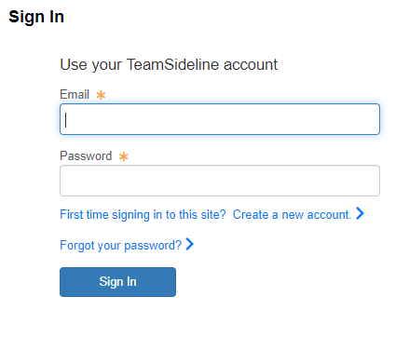
- Your account is now set up
How to register your adult athletics team on TeamSideline
- Click PLACE ORDER
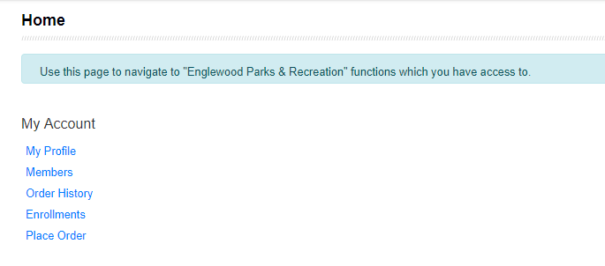
- Enrollee = your name
- Enrollment Type = General
- Program = Select the Season & Sport (e.g. Winter Basketball or Winter Volleyball)
- Offering = Select the Night & League (e.g. Sunday Men’s Comp or Wed Women’s D2)
- Click Add Enrollment
- Click Proceed to Checkout
- Enter your team name as you want it to appear on the game schedule. (Inappropriate team names may be subject to changes.)
- Answer any Program Specific Information that is required
- Read the Adult Sports League Roster Waiver section. Click the agreement button.
- Read the Code of Conduct section. Click the agreement button.
- Click Next
- Confirm your billing information
- Complete your payment information (Visa, MasterCard, or Discover)
  - Your statement will show a charge from “Englewood Parks & Recreation.”
- You have the option to pay 50% of the team fee at the time of registration or the full amount.
  - If you select paying the 50% option, the remaining balance is due by the registration deadline or your team will not be added to the game schedule.
  - TEAM FEES MUST BE PAID IN FULL IN ORDER TO BE PLACED ON THE GAME SCHEDULE.
- Click Place Order
Note: You will enter your Roster after you have registered your Team. An "Order Confirmation" page will display after you have registered your Team. When the "Order Confirmation" page displays, you can click your Team Name link under the "Manage Rosters" menu at the top of the page to enter your Roster. 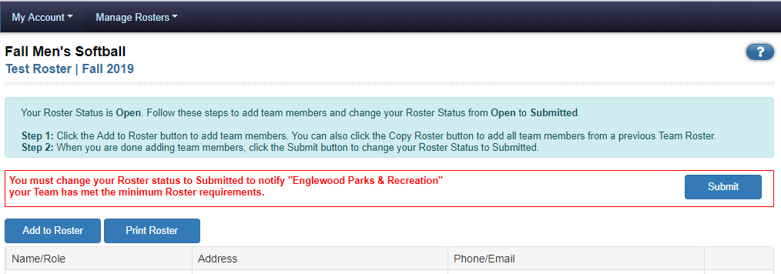
-or - 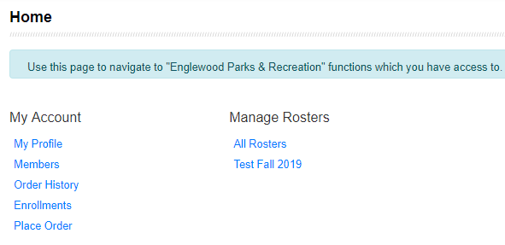
FAQ’s
- Can I register my team without submitting my roster?
  - YES – you can register your team without submitting a complete roster.

- Can I use my same roster from last season?
  - YES – you can copy your roster from one season to the next after your first season using the new TeamSideline.

- What if I need to add players to my roster after the roster deadline?
  - You cannot add players after the roster deadline. The roster will be frozen.

- What if I registered my team for the competitive league when my team should be in the recreational league (or vice versa)?
  - The Athletics Program Administrator (Sara) will be able to move teams to the appropriate division if needed.

Contact Sara at Sstant@englewoodco.gov or 303-762-2694 with any questions.

