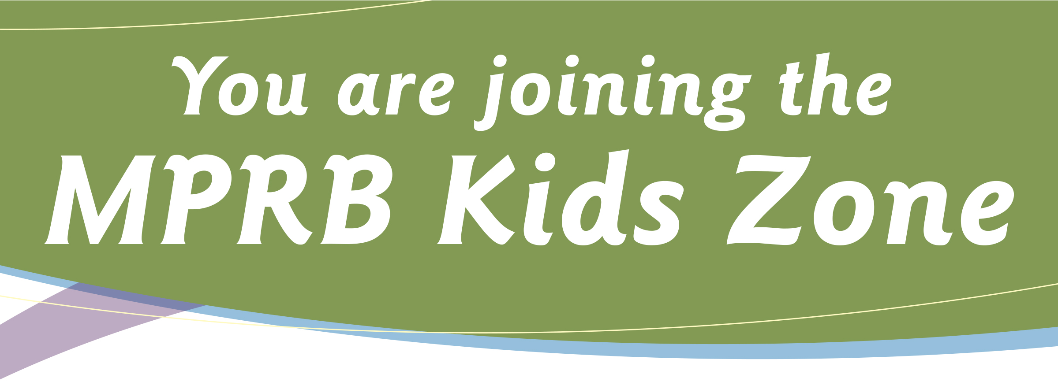

By registering your child in MPRB Youth Athletic leagues you
are joining the MPRB Kids Zone and agree to the following:

• Kids are #1

• FUN is more important than winning

• Let the coaches do the coaching

• Fans cheer positively (no public displays of anger)

• Respect the officials

• Inappropriate language will not be tolerated

• Keep the facility & grounds clean

• All parks and schools are tobacco & alcohol free

• Be a positive role model

Thank you for supporting MPRB athletics!
The Minneapolis Park & Recreation Board will provide all participating youth with a positive and safe environment. We welcome your ongoing support of our program.

Help keep kids in sports! Support! Encourage! Care!
Flag Football Bulletin: 6U & 8U Leagues

LEAGUE OBJECTIVES
- 6U/8U Flag Football will play under the rules of NFL Flag Football. The MPRB bulletin highlights modifications and clarification of certain rules.
- Encourage all players participation
- Develop basic soccer skills in all participants
- Foster an environment where sportsmanship and self-esteem building come first
- Everyone involved has a positive experience
- This is an instructional league and SCORE IS NOT KEPT – it is not about winning or losing and especially not about beating your opponents.
- All Players should rotate through all positions.
- Encourage and exemplify good sportsmanship. Encourage compliments to opposing players for their good efforts.

Players
- 6U Leagues – players 5-6 years or entering Kindergarten and 1st grades
- 8U Leagues – players 7-8 years or entering 2nd and 3rd grades
- Games will be 7 on 7. Players may be borrowed from the opposing team if needed.
- Roster limit: 12 players

Equipment
- No shirt or pants/may cover any portion of a player’s flags. Players’ shirts must be tucked in the player’s pants if they hang below the belt line.
- Each player on the field must wear a belt with two flags attached on right and left of player.
- Official game ball is a PEE WEE size ball.

Game Time
- All games will be two 20 minute halves with running time. The clock stops for timeouts and injuries. Halftime shall be 5 minutes.
- Timeouts: Each team receives 1 timeout per half.
- Play Clock: Each team must run a play 30 seconds after the end of the previous play.

Field
- The playing field shall 30 yards by 70 yards with two 10 yard endzones and a midfield line.
- No-run zones are marked at 5 yards on each side of midfield and 5 yards from each goal line.
Running plays are prohibited inside the no-run zones.

Game Procedures
- A pre-game coin toss will determine which team receives the ball first. The winner of the coin toss gets to choose to take the ball at the start of the game or at the start of the second half.
- The offense starts their possession at the 5 yard line and has 4 plays to cross midfield. When the offense crosses midfield, they will have 4 plays to score a touchdown.
- If the offense fails to cross midfield, the ball changes possession and the new offensive team starts a their 5 yard line.
- All possession changes, except interceptions, start at the offense’s 5 yard line.
- Interceptions will not be returned. The ball will be spotted at the spot of the interception.
- If a safety occurs, the defensive team will gain possession of the ball on their own five yard line.
- Teams change directions in the second half.

OFFENSE

Running Plays
- The QB cannot run directly with the ball. The QB must hand off, lateral or throw the ball.
- The ball is spotted where the runner’s front foot lands, not where the ball is located.
- Multiple laterals and pitches are permitted BEHIND the line of scrimmage. Any pitch or lateral that touches the ground is dead.
- The player who takes the handoff or lateral MAY throw the ball from the line of scrimmage. The defense may then cross the line of scrimmage to make a play on the offensive player.
- Ball carriers must make an effort to AVOID a defender with an established position.
Passing Plays
- Passes must be thrown from behind the line of scrimmage.
- Only one forward pass per play is allowed.
- Once the quarterback has lateraled or handed off the ball, all defensive players are eligible to cross the line of scrimmage.
- The quarterback has a 7 second pass clock. Failure to pass with 7 seconds will result in a dead play.
- Multiple laterals and pitches are permitted BEHIND the line of scrimmage. Any pitch or lateral that touches the ground is dead.

Receiving Plays
- All players are eligible to receive a pass (including the quarterback if the ball has been handed off behind the line of scrimmage).
- A player must have at least one foot inbounds when making a reception.
- If there is simultaneous possession by both offense and defense, possession will be awarded to the offense.
DEFENSE
- Blocking or tackling is prohibited.
- Interference with a receiver before a catch is not permitted.

Rushing the Passer
- Defensive players may not rush the QB position. Once the ball is lateraled or handed to another player (RB of WR) the defensive player may cross the line of scrimmage to defend the offensive player.
Pulling the Flag
- A legal flag pull takes place when the ball carrier is in control of the ball.
- Defenders may dive to pull a flag but not tackle, hold or run through the ball carrier.
- It is illegal to attempt to strip or pull the ball from the ball carrier’s possession.
- If a player’s flag inadvertently falls off during a play, the player is down immediately upon possession of the ball and the play will be whistled dead.
- A defensive player may not intentionally pull the flags off a player who is not in possession of the ball.
- Flag guarding is not allowed. A ball carrier may not obstruct the defender’s access to the flags by stiff-arming, dropping of the head, hand, arm or shoulder. The ball carrier may not intentionally cover the flags with the ball or jersey.
Formation
- An offensive team must have a minimum of four players on the line of scrimmage.
- The quarterback must be off the line of scrimmage.
- Only one player is allowed in motion at a time. All motion must be parallel to the line of scrimmage.
- The center must snap the ball with a rapid and continuous motion to a player in the backfield and the ball must be completely leave the player’s hands. The ball can be snapped between the legs of off to one side.

Penalties
- Penalties will be called by coach/referees.
- All penalties assessed from the line of scrimmage.
- All defensive penalties result in an automatic first down.
- All offensive penalties result in a loss of 10 yards with the exception of a penalty committed inside the offense’s 10 yard line. The penalty yards will be half the distance to the goal line.

Additional Notes:
- All volunteers must be background checked.
- All coaches must be certified through their home park and shall comply with the rules and regulations as stated in the bulletin.
- The MPRB does not discriminate on the basis of disability in the admission or access to, or treatment or employee in, its services, programs, or activities. Upon request, accommodation will be provided to allow individuals with disabilities to participate in all MPRB services, programs and activities.
- If anyone believes he or she has been subjected to discrimination on the basis of race, color, gender, national origin, age, or handicap, he or she may file a complaint alleging discrimination with the Minneapolis Park and Recreation Board or the Office of Equal Opportunity, U.S. Department of Interior, Washington, D.C. 20240

