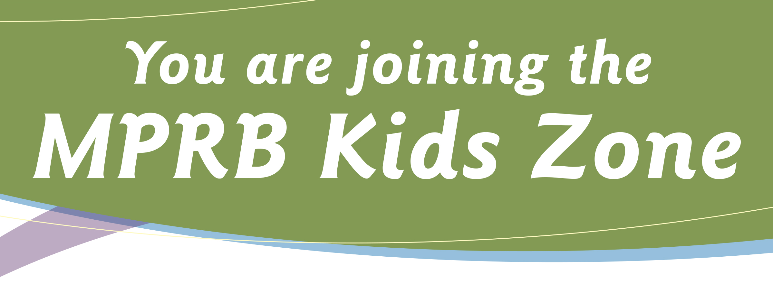

By registering your child in MPRB Youth Athletic leagues you
are joining the MPRB Kids Zone and agree to the following:

• Kids are #1

• FUN is more important than winning

• Let the coaches do the coaching

• Fans cheer positively (no public displays of anger)

• Respect the officials

• Inappropriate language will not be tolerated

• Keep the facility & grounds clean

• All parks and schools are tobacco & alcohol free

• Be a positive role model

Thank you for supporting MPRB athletics!
The Minneapolis Park & Recreation Board will provide all participating youth with a positive and safe environment. We welcome your ongoing support of our program.

Help keep kids in sports! Support! Encourage! Care!
Soccer Bulletin: 6U & 8U Leagues

LEAGUE OBJECTIVES
- Encourage all players participation
- Develop basic soccer skills in all participants
- Foster an environment where sportsmanship and self-esteem building come first
- Everyone involved has a positive experience
- This is an instructional league and SCORE IS NOT KEPT – it is not about winning or losing and especially not about beating your opponents.
- All Players should rotate through all positions.
- Encourage and exemplify good sportsmanship. Encourage compliments to opposing players for their good efforts.

Players
- 6U Leagues – players 5-6 years or entering Kindergarten and 1st grades
- 8U Leagues – players 7-8 years or entering 2nd and 3rd grades
- Teams should field a minimum of 6 players at all times when possible. Players may be borrowed from the opposing team if needed.
- Roster limit: 12 players

Weather/Field Conditions:
- For cancellations please call the field location starting at 9:00am on game day.
- Soccer is a game that is played in all weather. Games are to be played unless there is unsafe or severe weather (lightening, tornadoes, etc.)

Equipment:
- Players must wear tennis shoes or soccer shoes with molded rubber cleats.
- All players should wear shin guards with long socks over them.
- It is strongly recommended that goalkeepers wear elbow and kneepads.
- Each player should wear a different number.
- Ball Size: Size 3 ball for 6U; Size 4 ball for 8U.
- Coaches will provide the game ball.

Playing Field:
- 6U: The playing field will be 30 yards wide, 40 yards long. Game will be 6-on-6. Goal sizes will be determined by pop up goals.
- 8U: The playing field will be 40 yards wide, 60 yards long. Games will be 6-on-6. Goal sizes will be the soccer goals.

Game / Playing Rules:
F.I.F.A. (Fed. Inter. De Football Association) Rules will apply except for modifications stated below:
- Length of the Game:
- There will be two– 20-minute segments, with a 2-minute break for halftime.
- All games are running time.
- Teams have 60 minutes of field use. This time includes warm-up and duration of game.
- All players must play the equivalent of ½ of each game.
- Coaches are encouraged to provide each player with game experience in a variety of positions.
- Substitutions may be made with the consent of the referee (coach on field) at these times:
- Prior to a throw in your favor
- Prior to a goal kick by either side
- After a goal by either team
- After an injury when the coach stops play
- A goalkeeper cannot be touched or charged when in control of the ball in the penalty area. The goalkeeper cannot be charged when in the air playing the ball. The goalkeeper must have a free path when punting or throwing the ball.
- All goal kicks must emanate from the goal box.
- The Offside Rule will NOT be enforced.
- In case of injury, and a child is unable to play half of the game, the coach should notify either the referee (a coach) or the other coach before the game begins. If injury occurs during the game, the game should be stopped and appropriate First Aid should be administered and an Incident Report (available at Park’s Front Desk) filled out, and a new player will have to take the injured player’s position.
- No protests will be considered on ANY games.

Additional Notes:
- All volunteers must be background checked.
- All coaches must be certified through their home park and shall comply with the rules and regulations as stated in the bulletin.
- The MPRB does not discriminate on the basis of disability in the admission or access to, or treatment or employee in, its services, programs, or activities. Upon request, accommodation will be provided to allow individuals with disabilities to participate in all MPRB services, programs and activities.
- If anyone believes he or she has been subjected to discrimination on the basis of race, color, gender, national origin, age, or handicap, he or she may file a complaint alleging discrimination with the Minneapolis Park and Recreation Board or the Office of Equal Opportunity, U.S. Department of Interior, Washington, D.C. 20240

