Lindbergh
Community Education & Recreation
Volleyball League
Grades 3-8


COACHING MANUAL
& OFFICIAL RULES
2024
Contents
PHILOSOPHY OF PROGRAM 3
PURPOSE OF PROGRAM 3
SPORTSMANSHIP 3
FACILITY CODE OF CONDUCT 3
CODE OF CONDUCT 4
COACHES, SPONSORS, CHAPERONES 4
INCLEMENT WEATHER PROCEDURE 5
FOR PRACTICES AND GAMES 5
Required Coaching Clinic 5
Coaching to make a positive difference! 5
By Coaching Coaches, LLC 5
Recommended Heads Up to Youth Sports 5
MSHSAA INFECTIOUS DISEASE POLICY 6
BLOOD-BORNE INFECTIOUS DISEASES 6
The universal precautions when BLEEDING occurs 6
COMMUNICABLE DISEASE AND SKIN INFECTION PROCEDURES 8
The universal hygiene protocol for all sports 8
Infectious Skin Diseases 8
Blood-Borne Infectious Diseases Exposure Precautions 8
First Team Meeting (with parents) 9
CODE OF CONDUCT - PARENTS, GUARDIANS, SPECTATORS 10
CODE OF CONDUCT - PLAYERS 11
LEAGUE RULES 12
RULE I –Facilities 12
RULE II – Equipment 12
Rule III – Participants 13
Rule IV - Player’s Equipment 13
Rule V – Rights and Responsibilities 14
Rule VI – Point, Game, and Match Winner 15
Rule VII - Pre-Match Conference/Coin Toss 16
Rule VIII – Rotation Order 16
Rule VIV – Player Positions 16
Rules X – Substitution and Time Outs 17
Rule XI – Serving 18
Rule XII – Playing Actions 19
RULE XIII – Fouls 20
Rule XIV - Unsportsmanlike Conduct 21
Service Zones & Court Dimensions 22
Line up sheet for matches (3rd – 6th Grade) 25
Line up sheet for matches (7th – 8th Grade) 26
2024 VOLLEYBALL RULES 27
Links 27

PHILOSOPHY OF PROGRAM
Lindbergh Community Education and Recreation provides lifelong learning and recreation opportunities to community members. Our programs strive to develop an atmosphere that emphasizes learning, teamwork, sportsmanship, resiliency, and enthusiasm. We strive to have all those participating (players, coaches, managers, parents, fans, officials, etc.) uphold the Lindbergh Schools Values and Ethics when involved with our programs.

PURPOSE OF PROGRAM
To provide a program for children which:
- Teaches the FUNdamentals of the game.
- Develops attitudes of teamwork and good sportsmanship.
- Provides wholesome family and friendship oriented recreation.
- Emphasizes FUN.

SPORTSMANSHIP
Lindbergh Community Education and Recreation takes great pride in the way its parents and students handle themselves at all activities. For any athletic event or activity to occur, officials, coaches, players, and spectators must interact. This interaction is the key to much of the experience players receive from these activities. We expect all of our participants to demonstrate courtesy and good sportsmanship. Degrading the other team by booing, cursing, or any other form of inappropriate behavior is unacceptable. Participants will accept the officials’ ruling without argument. Any violation of the above will result in a tactful ejection from not only the present game but, at a minimum, will not be allowed to manage/coach/watch (for spectators) in the next two scheduled games. Depending on the violation, the penalty can be up to/and including suspension from any Lindbergh Community Education and Recreation activity going forward.

FACILITY CODE OF CONDUCT
Lindbergh Community Education and Recreation is fortunate each year to be allowed to use the facilities at all schools in the district for the purpose of running effective programs for our student-athletes. It is our job to continue to show common courtesy when granted access to these schools/facilities. We ask that all coaches, players, parents, spectators, and siblings respect Lindbergh facilities at all times when participating in practices and games. Any horseplay and other unacceptable behavior around the fields or in/around the schools/facilities will not be tolerated. Team misconduct reported to our office from schools could result in temporary to permanent suspension from future use of that school and temporary or permanent suspension from the program.

CODE OF CONDUCT

COACHES, SPONSORS, CHAPERONES

Participation in school and district activities and athletic events are an important part of our students’ education and development. With your employment as a coach or sponsor comes a great responsibility to protect the well-being of each of our students. It is your job to ensure that each student is treated with respect and accorded the opportunity to develop what he or she needs and deserves.

This Code of Conduct has been written for all personnel who will be working with our students in activities. All coaches and sponsors should take time to review this document thoroughly and reflect on its implications for their particular role. Veteran coaches and sponsors should annually review the district’s expectations.

Coaches and sponsors must adhere to the following standards of conduct. It is important for all coaches and sponsors to understand that this list is not exhaustive. It is intended to provide specific, but not exclusive, examples of the standards of conduct that are appropriate for persons who coach and sponsor student activities.

- It is your responsibility to speak and act respectfully to all students, staff, parents and members of the public.
- Possession of or use of alcohol, drugs and/or tobacco or being under the influence of drugs and/or alcohol is not permitted while in the company of students whether on or off district property. Adults are not to consume alcoholic beverages when supervising students on out of town or overnight field trips so as not to risk having impaired judgment should they need to make a decision on a student's behalf. For purposes of this Regulation, adults are considered to be supervising students at all times during out of town or overnight field trips.
- Remarks that refer to an individual’s race, sex, religion, national origin or mental or physical disability are not permitted.
- Language or jokes that may be offensive to others are not permitted.
- Clear notice must be given when entering locker rooms or other private areas occupied by members of the opposite gender.
- Coaches and sponsors must not have physical contact with students that are likely to cause the student to be uncomfortable.
- Fraternization between coaches and students is strictly prohibited. This includes close personal or special relationships, dating and/or sexual contact.
- Sexual harassment of any person is expressly prohibited. Coaches and sponsors must refrain from all gestures, comments or physical contact that a reasonable person may judge as unwelcome.
- Threatening comments or profane language damaging to students’ self-esteem are not permitted.
- Extreme care should be used to monitor the physical condition of students. This is particularly important in extremely cold or hot weather.
- Coaches and sponsors are encouraged to pay attention to and develop all students to his/her individual potential.
- When traveling with students, coaches and sponsors are prohibited from visiting the accommodations of individual students one-on-one.
- Except in an emergency that threatens the life or immediate safety of a student or other person, coaches and sponsors may not drive students home (or to any other location) from practice or events, if by doing so, the coach or sponsor will, at any time during the drive, be alone with one student.
- Private tutoring for compensation must not occur with students that you coach, teach or sponsor during the school year if said tutoring is in conflict with district policy.
- The sale of personal objects or general merchandise not endorsed by the district is not permitted.

INCLEMENT WEATHER PROCEDURE

FOR PRACTICES AND GAMES

- For Practices: If there is an early release or no school due to inclement weather, there will not be practice that night.
- For Games: Decisions regarding game cancellations will be made prior to the game with as much advanced notice as possible. Lindbergh Community Education and Recreation will schedule make-up games, teams will no longer be required to schedule their own make-up games.
- For up-to-date field status, please call the Rainout Hotline at (314) 730-1133.

Required Coaching Clinic

Coaching to make a positive difference!

By Coaching Coaches, LLC

All coaches are now required to watch, complete, and pass the following coaching clinic – “Coaching to Make a Positive Difference” from Coaching Coaches’ Bill Bommarito. If you have already completed this course because you coach with CYC, you will need to provide a copy of your certificate of completion to our office or call us with the certification ID number so we can verify with the CYC office. If you don’t have either of these and you have completed this course, you will be responsible for contacting the CYC office and getting that information from them and then providing that to our office.

All of this MUST be done before your first contest/game! The course is two hours long, but can be taken in ten minute increments. We would prefer that you get this done before your first practice, but it’s required before your first match.

Here is the link - Coaching to make a positive difference

Recommended Heads Up to Youth Sports
“To help ensure the health and safety of young athletes, CDC developed the HEADS UP Concussion in Youth Sports initiative to offer information about concussions to coaches, parents, and athletes involved in youth sports. The HEADS UP initiative provides important information on preventing, recognizing, and responding to a concussion.” Here is the link – Heads Up to Youth Sports

MSHSAA INFECTIOUS DISEASE POLICY

If an athlete sustains a minor bleeding problem during the course of the game, please remind the officials that they should address the situation per Missouri State High School Activities Association rules. Attached is the copy of the policy for your information.

Also, please make arrangements with the custodian on site for a cleanup and proper supplies.

BLOOD-BORNE INFECTIOUS DISEASES
The MSHSAA Board of Directors has adopted the following policy in an effort to minimize the possibility of any transmission of HIV and the resulting Acquired Immune Deficiency Syndrome (AIDS). Although the policy was originally written with the sport of wrestling in mind, it is applicable for all sports. The MSHSAA Board of Directors also strongly recommends that each school adopt a similar policy to apply to any situation in which an injury might occur which results in bleeding. Such injuries are most likely to occur in physical education classes, athletic practice sessions, and contests. Therefore, it is extremely important that teachers, coaches, and referees follow the procedures outlined in the policy and be cognizant that any time there is blood present that it be treated with respect regarding its ability to transmit infectious diseases.

Health-care workers, including doctors and athletics trainers, who care for student-athletes should employ the universal precautions currently recommended by Centers for Disease Control in the care of all athletes, since medical history and examination cannot reliably identify patients infected with HIV:

The universal precautions when BLEEDING occurs

- Routine use of barrier precautions to prevent skin and mucous-membrane exposure when contact with blood or other body fluids is anticipated. Gloves should be worn for touching blood, bloody fluids, mucous membranes or nonintact skin (e.g., abrasions, dermatitis) of all athletes for handling items or surfaces soiled with blood or body fluids, and for performing venipuncture. Gloves should be changed after contact with each student-athlete. Masks and protective eye wear or face shields should be worn during procedures that are likely to generate droplets of blood or other body fluids to prevent exposure of mucous membranes of the mouth, nose, and eyes.
- Hands and other skin surfaces should be washed immediately and thoroughly if contaminated with blood and other body fluids. Hands should be washed immediately after gloves are removed.
- Surfaces contaminated with blood should be cleaned with a solution made from a one-to-hundred (1:100) dilution of household bleach.
- Precautions should be taken to prevent injuries caused by needles, scalpels and other sharp instruments or devices. To prevent needle stick injuries, needles should not be recapped, purposely bent or broken by hand, removed from disposable syringes, or otherwise manipulated by hand.
- Although saliva has not been implicated in HIV transmission, to minimize the need for emergency mouth-to-mouth resuscitation, mouthpieces, resuscitation bags or other ventilation devices should be available for use.
- Health-care workers who have exudative lesions or weeping dermatitis should refrain from all direct patient care until the condition resolves.
- Soiled linen should be bagged and washed in hot water with detergent.
- In the athletics environment, universal guidelines should be considered in the immediate control of bleeding and when handling bloody dressings, mouth guards and other articles containing bodily fluids.

Member institutions should ensure that policies exist for the orientation and education of all health-care workers on the prevention of transmission of HIV and the need for routine use of the above universal precautions. Additionally, provision of equipment and supplies necessary to minimize the risk of infection, as well as the monitoring of adherence to recommended protective measures, need to be guaranteed. In the area of interscholastic activities, some alarm has been expressed regarding the presence of HIV in sweat, saliva and bleeding from minor injuries. Some important things to remember are:

- At this time, it is uncertain that the AIDS virus is transmitted by either saliva or sweat. Therefore, efforts need to be concentrated in the area of the minor injuries that result in bleeding.
- Proper handling of these situations by coaches, officials and competitors will greatly reduce the possibility of any transmission of AIDS, if indeed the athlete who is bleeding is infected by the disease.
- The possibility of transmitting AIDS in this manner is much less than the possibility of transmitting other very dangerous blood-borne viral infections such as Hepatitis B.
- However, the chance of transmitting the AIDS virus is not zero. Therefore, precautions should be taken to insure that no transmission can occur.
- If an athlete sustains a minor bleeding problem -- and most bleeding problems in sports result from minor injuries in the nose area -- the contest should be stopped, the bleeding stemmed, and any blood on the playing surface should be wiped off using a disinfectant such as Clorox, in a 100 to 1 solution (100 parts water and one part disinfectant). This same solution should be used to wipe any blood off the opponent's skin. However, the area should then be rinsed with water to avoid either participant getting the disinfectant in his eyes. It should be noted that there are also many other disinfectants that are very successful in combating HIV such as isopropyl alcohol.

If any of the blood has gotten on the opponent's uniform, unless the opponent has an open cut or unskinned area on his body, it is not necessary to clean the uniform at this point. If there is an open cut or unskinned area then the uniform should be wiped with the disinfectant solution and then thoroughly rinsed with water to avoid either participant getting the disinfectant in his eyes.
If an official should get blood on himself, he should do the same as the competitors -- use the disinfectant solution to wipe the area of the blood.

NOTE: Disposable towels should be used in all clean up and then placed in a sealed container near the mat. Also, extreme care should be used in disposing of cotton used to stem bleeding.

COMMUNICABLE DISEASE AND SKIN INFECTION PROCEDURES
While the risk for blood-borne infectious diseases, such as HIV/Hepatitis B, remains low in sports, proper precautions are needed to reduce the risk of spreading diseases. Along with these issues are skin infections that occur due to skin contact with competitors and equipment.

Note: Infectious skin diseases include those caused by Staphylococcus aureus (Staph infections) and by methicillinresistant Staphylococcus aureus (MRSA), which are more difficult to treat.

The universal hygiene protocol for all sports
- Shower immediately after all competition and practice.
- Wash all workout clothing after practice.
- Wash personal gear, such as knee pads, periodically.
- Don't share towels or personal hygiene products with others.
- Refrain from cosmetic shaving.

Infectious Skin Diseases

Means of reducing the potential exposure to these agents include:
- Notify guardian, athletic trainer and coach of any lesion before competition or practice. Athletes must have a health-care provider evaluate lesions before returning to competition.
- If an outbreak occurs on a team, especially in a contact sport, consider evaluating other team members for potential spread of the infectious agent.
- Follow NFHS or state/local guidelines on “time until return to competition.” Allowance of participation with a covered lesion can occur if approved by a health-care provider and in accordance with NFHS, state or local guidelines.

Blood-Borne Infectious Diseases Exposure Precautions
Means of reducing the potential exposure to these agents include:

- Bleeding must be stopped immediately and all wounds covered. All blood-soaked clothing must be removed before continuing competition or practice. Contaminated clothing must be cleaned before using again.
- Athletic trainers or caregivers need to wear gloves and take other precautions to prevent blood-splash from contaminating themselves or others.
- Immediately wash contaminated skin or mucous membranes with soap and water.
- Clean all contaminated surfaces and equipment with disinfectant before returning to competition. Be sure to use gloves with cleaning.
- Any blood exposure or bites to the skin that break the surface must be reported and evaluated by a medical provider immediately.

First Team Meeting (with parents)

- As soon as you obtain your roster and practice schedule from the league, call or email your parents and introduce yourself.

- Set up your first team meeting to be held at your first available practice time and make sure to ask all parents to attend this meeting.

- Prepare a written introduction of yourself and include in your notes; expected practice schedule, equipment information (such as size of ball, type of ball, etc), uniform expectations, your manner of player discipline, and what you expect from your parents.
  - A short introduction including your coaching philosophy will help the parents become more comfortable with you and your coaching efforts.
  - A review of the league rules and guidelines with parents will clear up a lot of confusion when it comes to playing regulations.
  - Let the parents know you appreciate their help and support, but also tell
them not to interfere with your coaching directions to the players during
practice or at a game.

- During your first team meeting, ask for assistant coaches from the parent pool but don’t forget about your player’s older siblings. Some of your best coaches and role models can be older siblings who know the game.

- Accept anyone who volunteers. Let the coaches know that you will expect them to be at every practice and game (if they can), and assign each coach a specific duty. Anyone working directly with the players will need to fill out all the required forms and training.

- Assign parents to a call chain. Each parent will be assigned a parent to call if there is a late cancellation of practice so you aren’t stuck making all of the phone calls. Emails should be used if it is a planned cancellation. In the case that practice is canceled at the last minute, phone calls are the appropriate form of communication.

- Introduce each coach to the players.

- Share the Code of Conducts for parents/spectators and players.

CODE OF CONDUCT - PARENTS, GUARDIANS, SPECTATORS

Lindbergh Community Education and Recreation works to provide a valuable experience for all patrons through various athletic programs. Part of the experience includes ensuring a safe and enjoyable environment for participants, spectators, and staff of programs. As a result, the following code of conduct has been created for all Lindbergh Community Education and Recreation sports activities.

As a parent/guardian of a player or a spectator of the game, I will abide by the following guidelines
- Remain in the spectator areas during all games and keep other members of my family/friends in the assigned spectator area.
- Learn the rules of the game so I can better understand what is happening.
- Model sportsmanship for my child by treating all coaches, officials, supervisors, players and spectators of either team with courtesy and respect.
- Applaud good and fair play during games.
- Understand that physical or verbal intimidation, abusive language or inappropriate gestures are unacceptable behavior.
- Respect the integrity of the officials/game committee/site supervisor and not advise them how to call the game.
- Not advise the coach on how to coach, who to put in or who to take out of the game and not coach my child during the game.
- Address questions regarding team activities to the coach. If questions or concerns still have not been addressed satisfactorily, then address with the Lindbergh Community Education and Recreation Sports Supervisor, but not with others.
- Protect the ability to continue using the facility by following all the rules of the facility: such as no alcohol/drugs/tobacco possession or use, throwing all trash in an appropriate receptacle, controlling additional attendees (such as siblings, etc.)

I understand that it is a privilege and not a right to attend games/practices. If I violate this Code of Conduct, I understand that
- I may be required to leave the facility.
- My child’s team may be penalized for my behavior.
- I may not be permitted to attend future Lindbergh Community Education and Recreation sponsored activities and events.

CODE OF CONDUCT - PLAYERS

Lindbergh Community Education and Recreation works to provide a valuable experience for all patrons through various athletic programs. Part of the experience includes ensuring a safe and enjoyable environment for participants, spectators, and staff of programs. As a result, the following code of conduct has been created for all Lindbergh Community Education and Recreation sports activities.

As a player of the game, I will abide by the following guidelines
- I will remember that games are played for fun!
- I will display good sportsmanship ahead of my own personal desire to win.
- I will demonstrate good sportsmanship regardless of the score by acting in a positive manner towards all players, officials, parents and coaches. Example – assisting another player up after they have fallen down.
- I will show respect to all game officials, coaches, players, and parents..
- I will not use drugs, tobacco or alcohol at any practice or game and will remind others on my team not to do so.
- I will shake hands with the other team at the conclusion of all games.

I understand that if I violate this Code of Conduct that
- I may have to leave the facility.
- My team may be penalized for my behavior.
- I may not be permitted to participate in future Lindbergh Community Education and Recreation sponsored events.

LEAGUE RULES
RULE I –Facilities

Section 1 – Dimension

- The maximum dimension of the court should be 60 feet long by 30 feet wide, with approx. 6’6” area around the court free of obstructions.
- Boundary lines must be a color contrasting to that of the floor.

Section 2 – Service Area

- 3rd - 4th grade may use the service box 10 feet from the endline and from the sideline (this will be marked on the court).
- 5th - 6th grade may use a service box 6’6” feet from the end line and 10 ft from the sideline (this will be marked on the court).
- 7th - 8th serves from behind the end line.

Section 3 – Ceiling Clearance
A ball, other than the serve, may strike the ceiling or other fixture or obstruction over a playable surface which intrudes on the height of the court or that of the surrounding playing area and still be in play as if it had not touched the obstruction. However, no such ball may legally strike above the opponent’s side of the net nor may it hit on your side and fall into your opponent’s playing area. In touching the ceiling obstructions, if the ball becomes wedged, the referee shall call a replay unless it was the 3rd hit and then a point is awarded.

RULE II – Equipment

Section 1 – Net

- The top of the net should be 6’6” from the floor at the center for the 3rd - 4th grade teams.
- The top of the net should be 7’ from the floor at the center for 5th - 6th grade teams.
- The top of the net should be 7’4 ¼ “ from the floor at the center for 7th - 8th grade teams.

Section 2 – Ball

- Volleyballs will not be furnished by the Community Education and Recreation Dept.; each player should provide their own ball for practices.
- Community Ed & Rec will provide the ball for all league games.
- Grades 3-6 will use Volley Lite volleyballs.
- Grades 7-8 will use regulation volleyballs.

Rule III – Participants

Team Composition
A team may consist of players, coaches, and managers as identified on their team roster. Only identified team members may sit on the bench. In all divisions, a complete team shall consist of 6 players. No game may be played with less than 5 players.

Note: If a team has only 5 players, their positions will be Left Back (5), Left Front (4), Middle Front (3), Right Front (2) and Right Back (1). Middle back position shall be designated as position #6 & the positions shall be numbered clockwise to #1.

Note: For official scorekeeping purposes, there will be no loss of service when the missing player is due to serve.

Late players may be allowed to enter the game in progress; providing they enter using the appropriate substitution method for that grade level (i.e. 3-6th grade player would enter into the player #6 spot, middle back).

Injured players: Players that are removed from the game shall not be allowed to reenter the game in which they were injured unless injury took place when the player was legally substituted for (i.e. 3-6th grade would be in position 6).

- Only registered members may participate in the match.
- A team consisting of more than one grade of girls will play in the grade category of the oldest member.
- Rosters and registrations must be completed before the first league game is played.

Rule IV - Player’s Equipment

Section 1 – Uniforms

- Uniforms are the t-shirts provided to the players by the Lindbergh Community Education and Recreation department and must be worn for matches to help identify the different teams.
- No hard casts are allowed. All metal or plastic components on braces must be covered.
- SHOES are considered player’s equipment and must be light and pliable with rubber or leather soles without heels. For safety reasons, shoe laces must be tied.
Section 2 – Forbidden objects and uniforms

- It is forbidden to wear hats/headgear/glitter/hair or body paint or jewelry. Taping of earrings is prohibited. ONLY SOFT PLIABLE HAIR ACCESSORIES ARE PERMISSIBLE.
- An exception will be made for religious or medical medallions; it shall be taped in such a manner as to not create a safety hazard.
- Casts, braces, prosthetic limbs or headgear that may cause an injury or give an artificial advantage to the player may not be worn. If a cast, brace, prosthetic limb or headgear is used, padding or covering may be necessary.
- Players may wear glasses or contact lenses at their own risk.

Rule V – Rights and Responsibilities

Section 1 – Basic Responsibilities

- Participants must know the Official Volleyball Rules and abide by them.
- Participants must accept referees’ decisions with sportsmanlike conduct and without dispute. In case of doubt, clarification may be requested through the playing captain. Participants must behave respectfully and courteously in the spirit of fair play, not only toward the referees, but also toward other officials, the opponents, teammates & spectators.
- Participants must refrain from actions or attitudes aimed at influencing the decisions of the referees or covering up faults committed by their team.
- Participants must refrain from actions aimed at delaying the game.
- Both the playing captain and the coach(es) are responsible for the conduct and discipline of their team members.

Section 2 – Captain

- The team captain represents the team in the coin toss at the pre-match conference.
- During the match, the team captain functions as the game captain only while on the court. When the ball is out of play, the game captain may speak to the referees.

Commentary: A coach may act instead of the game captain to:
- ask for an explanation of the application or interpretation of the Rules and to submit to the appropriate referee any requests or questions of teammates. If the explanation is not satisfactory, he/she must immediately indicate to the referee the right to record this disagreement on the scoresheet as an official protest.
- ask authorization to change equipment, to verify the positions of their own team, to check the floor, the net, the ball, etc., and
- request regular game interruptions.

Section 3 – Coach(es)

Commentary: A coach may stand during play to instruct players in a non- disruptive manner and may stand and move about to speak to team members and players, as long as they are at least 4-6 feet from the sideline. Acts deemed disruptive by the first referee shall be sanctioned. Examples of disruptive acts shall include, but are not limited to:
- loud or abusive language,
- comments to officials,
- comments to opposing teams,
- throwing of objects,
- displaying disgust in an overt manner, or
- interfering with proper officiating of the match.
- a coach may request a legal interruption only while at the team bench.

Rule VI – Point, Game, and Match Winner

Section 1 – Number of games/scoring

- A match shall consist of 3 games, games 1 and 2 are played to 25 points and game 3 is played to 15 points. In the case of a tie, play is continued until a two-point lead is achieved with a cap of 30 points.
- Rally scoring will be used for all grade levels.
  - If a team fails to serve properly, return the ball or commits any other fault, the opponent wins the rally and scores a point. The consequences of winning the rally are: Point. If the serving team wins the rally, it scores a point and continues to serve. If the receiving team wins the rally, it scores a point and gains the right to serve.
- For 3rd-6th Grade Teams - No player may serve more than 5 consecutive points. Example: When player A serves 5 consecutive points in a game, a sideout is declared (no point awarded) and Team B rotates and serves. When Team A regains possession of the serve, Team A will rotate before they serve.

Section 2 – Incomplete team during match
If a team is reduced to less than five players and cannot complete the remainder of a match, the opponents shall be awarded sufficient points and games necessary to win the match. The defaulting team retains their points and games won. The match can be completed in a scrimmage mode.

Section 3 – Game Forfeiture
There will be 5 minutes past the scheduled start time for the match allowed before the first game of the match is forfeited. An additional 5 minutes is allowed before the remaining two games of the match are forfeited.

Rule VII - Pre-Match Conference/Coin Toss

- Before the warm-up, the first referee conducts a pre-match conference (which the head coach must attend) and a coin toss in the presence of the two team captains. Home team chooses their bench as they take the court. Visiting team shall call the first toss. The winner of the coin toss chooses:
  - the right to serve or to receive the service
- Teams will no longer be required to switch sides after each game. The MSHSAA Board of Directors approved a state association adoption per rule 9-1-2 of the NFHS Volleyball Rules Book for teams to remain on the same benches throughout the match. In the event there is a clear and distinct disadvantage, teams may switch sides. Officials shall determine if a disadvantage is present.
- The home team will supply a scorekeeper for the match.

Rule VIII – Rotation Order

- Rotation order as determined by the starting line-up and must be maintained throughout the game.
  - For instance, don’t go back to your starting line up at the start of every game and have your first server of the next game be a different player, by rotating the players.
- There must be at least five players per team to begin a rally.

Rule VIV – Player Positions

Section 1 - Positions

- At the moment the ball is contacted by the server, each team must be completely within its own team court (except the server).
- Three players are front-row players and occupy positions 4 (left player), 3 (center player) and 2 (right player). The other two or three are back-row players occupying positions 5 (left player), 6 (center player) and 1 (right player).
- The positions of players are determined and judged according to the positions of their feet contacting the court as follows:
Commentary: The position of the players is judged according to the position
of the foot last in contact with the floor at the time the ball is contacted for service.
- Each front-row player must have at least a part of a foot closer to the center line than both feet of the corresponding back-row player.
- Each right (left)-side player must have at least a part of a foot closer to the right (left)-side line than both feet of the center player in the corresponding row. The server is exempt from the application of this rule.

Section 2 – Rotation
When the receiving team has gained the right to serve, its players must rotate one position clockwise (player in position 2 rotates to position 1 to serve, player in 1 rotates to 6, etc.)

Rules X – Substitution and Time Outs

Section 1 – Substitutions - A team may use two types of substitution in this league.

- 3rd-6th grade divisions: Use the rotation method of Substitution only. This is accomplished by substituting one player on every exchange of the serve. This exchange can only be made at position #6. The players will report up to the substitution zone (like a normal sub) and then sub into position 6 after ref approval. We are following rotation, but teaching the players the game. The rotation must continue in the same order for the entire match. The server at the end of one game must rotate before a serve begins for their team. She may not be the first server on their team after sides are changed.
7th- 8th grade: A team may use free substitution. This
is accomplished by substituting one or more players in any position.
Individual substitutions are unlimited. The player(s) must report to the sub
zone and wait approval before entering the court. We strongly encourage
teams to let the player rotate around to all 6 positions before rotating them
out.
- Injured players may be substituted for any position on the floor. If a legal substitution occurs, that player may reenter that game (per coach, parent, ref and site supervisor approval), otherwise the player may not reenter that game.
- Every uniformed player present must play in each game of each match. If injury or disciplinary action occurs during a game, the coach must notify the officials prior to the start of the next game. A player may be removed from a match in progress for disciplinary reasons. Remaining players will rotate forward to fill the spots and substitution (if possible) will take place. Failure of a player to appear in any game may cause forfeiture of that game. It is strongly recommended that each player is allowed to play in all six positions before being substituted. Failure to do so may result in forfeiture. Rec Supervisor has the authority to further discipline the coach or manager.
EXCEPTION
In case of injury, any position can be substituted at any time.

Section 2 – Time outs

- Time outs: Each team may ask for 2- 30 second timeouts per game.

Rule XI – Serving

Section 1 – Serving Line

- When a player steps on or over the serving line in the act of serving, a point is awarded to the other team. The player can step on or over the serving line immediately after contacting the ball or be in the air over the line when contact is made.
Exception: 3rd-6th grade divisions have separate serving areas.
- 3rd-4th Grade Serving – if the player misses their first serve, they get a reserve, but only on their very first serve.

Section 2 – No Contact
A player attempting to strike the ball in the act of serving and missing contact entirely, will not be considered as having served. If after releasing the ball, the server allows the ball to fall to the floor without being contacted, the serve shall be replayed (an additional 5 seconds are given to complete the serve). The player is only allowed to do this one time per each service rotation. If they let the ball drop twice in the same service rotation a side out and out point is awarded to the receiving team.

Section 3 – Out of Rotation/Illegal Server

- Serving out of rotation order is an illegal serve. A point is called and positions corrected immediately. The proper player serves when next gaining possession.
- No points made by an illegal serve shall count unless the error is not detected until after the opposing team serves. In this case, the error will not be penalized (no points are deducted). However, positions should be corrected immediately, if necessary, and the proper player should serve on the next possession.

Section 4 – Legal Serve

- The ball is put in play/served by hitting one handed, open or closed, while standing completely behind the serving line.
Exception: Grades 3-6 divisions.
- The server must wait for the referee’s whistle before putting the ball in play. The server has 8 seconds to serve after the whistle. Failure to serve in those 8 seconds results in a side out and a point for the receiving team.
- If a player serves before the whistle has blown, the referee will cancel the serve and order a replay. A warning is issued on the first offense. A repeated offense during the same service will result in a side out and point awarded to the receiving team.
- A net serve is a ball that touches the net, carries over the net, and lands within the court lines on the opposing team side, this is legal.

Section 5 – Serve Replayed
A serve is replayed for any of the following reasons:
  - A missed first serve for Grades 3 and 4, a second attempt will be allowed. A miss on any subsequent attempt during that service span will result in a side-out.
  - Double foul – both teams foul simultaneously.
  - Foreign object on the court – i.e., a ball from another court.
  - The first referee may call for a serve to be replayed at any time he/she deems it necessary.

Rule XII – Playing Actions

Section 1 – Ball in Play vs Out of Play

- The rally begins with the referee’s whistle. After the referee’s whistle, no other action may take place, i.e. substitution request, time-out request, etc. until the end of the rally. The ball is in play, however, from the service contact.
- The rally ends with the referee’s whistle. However, if the whistle is due to a fault made in play, the ball is out of play from the moment the fault was committed.
Commentary: In the case of an inadvertent whistle, the rally is ended. The first referee must make a ruling that will not penalize either team.

Section 2 – Ball In vs Out

- The ball is “in” when it touches the floor of the playing court including the boundary lines and travels inside the antennae when it crosses the net.
- The ball is “out” when:
  - no part of the ball contacts either a boundary line or the area within the boundary lines.
  - it contacts an object outside the court, the ceiling or a person out of play,
  - it contacts an antenna, rope, post, supporting apparatus or a part of the net itself outside an antenna/side band, or
  - completely crosses the vertical plane of the net, partly or totally outside the crossing space.

Section 3 – Playing the Ball

- Each team is entitled to a maximum of three hits (in addition to blocking – a block is NOT considered a teams’ first hit) to return the ball to the opponents.
- A player may not contact the ball with 2 separate and consecutive motions.
- If 2 or more players contact the ball at the same moment, it’s considered one contact (even if done by players on the same team).
  - If 2 opponents simultaneously contact the ball and it remains in play the team receiving the ball is entitled to another 3 hits. If such a ball goes “out” it is the fault of the team on the opposite side from where the ball lands.
- A ball may touch any part of a player’s body (including below the waist).
- During blocking, consecutive contacts may occur by one or more blockers provided the contacts occur during one action.
- You may NOT block or attack a serve.
- During the first hit of a team (not blocking), the ball may contact various parts of the body consecutively, provided the contacts occur during one action, but the ball may not be caught and/or thrown.
- In order for a back row player to attack a ball, the jump must start behind the 10 ft. line and contact with the ball must be made before crossing the 10 ft. line. A back row player may attack the ball in front of the 10 ft. if, at the moment of contact, any part of the ball is below the top of the net.
- Blocking is the action that deflects the ball coming from the opponent by a player(s) close to the net reaching higher than the net. Only front row players are permitted to complete a block. A block contact is not counted as a team hit. After a block contact, a team is entitled to three hits to return the ball to the opponent. The first hit after the block may be executed by any player, including the player who contacted the ball to complete the block.
- In blocking, a player may place hands and arms beyond the net, provided this action does not interfere with the opponents play during an executed attack-hit and is made after the opponents have hit the ball in such a manner that the ball would, in the referee judgment, clearly cross the net if not touched by a player and no member of the attacking team is in position to make a play on the ball.

RULE XIII – Fouls

Point/Side out
Any of the following fouls committed by the serving team shall result in a point for the receiving team. Any of the following fouls by the receiving team shall result in a point awarded to the serving team:
  - Touching the net or supports at any time other than when the ball is not in play (hair does not count as a contact).
  - An illegal serve.
  - Extended contact (such as lifting, holding, scooping, pushing, or throwing) of the ball in the act of playing it.
  - Penetration under the net (across the centerline) by any body part is illegal. If your hand or foot is still in contact with the centerline, then there is no fault. Play continues.
  - It is a fault to touch any part of the net or the antennas, except for a player’s hair.
  - A player may touch a post, rope or any other object outside the total length of the net provided this contact does not interfere with play.
  - When the ball is driven into the net and causes it to touch an opponent, no fault is committed.
  - Touches the ball or an opponent in the opponent’s space before or during the opponent’s attack-hit,

Rule XIV - Unsportsmanlike Conduct
Actions with intent to confuse opponents by yelling, interference, stomping, personal remarks, etc., should bring a referee’s warning. On continued offense, offending player(s) shall be removed from the game by the gym supervisor and reported to the Rec/Sports Supervisor. Further action may be taken up to and including removal from all future matches.

Service Zones & Court Dimensions

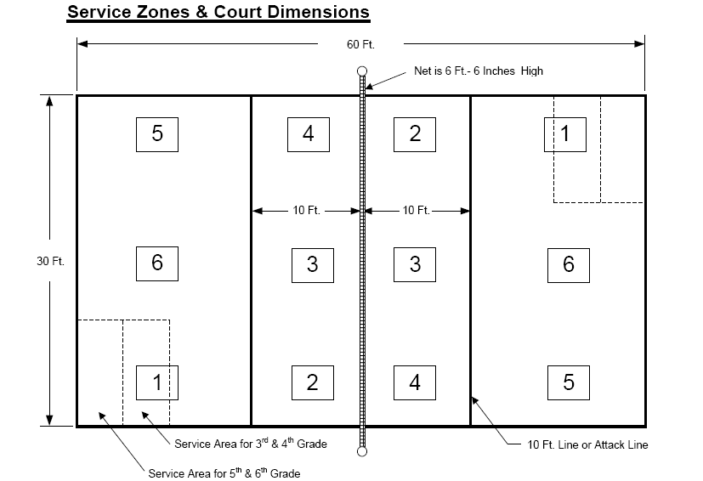
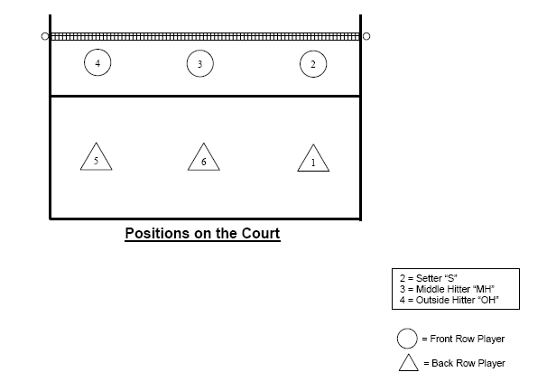
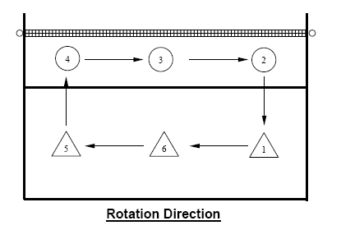
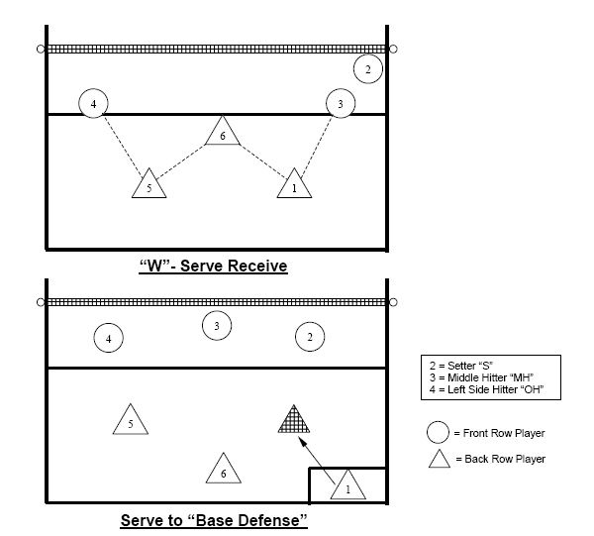
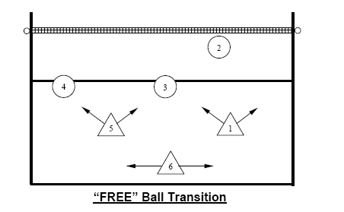

Line up sheet for matches (3rd – 6th Grade)

Rotation Method – 3rd -6th grade – must stay in this order for the whole match

 | Position |  | Name
Server/Rt Back | 1
Right Front | 2
Middle Front | 3
Left Front | 4
Left Back | 5
Middle Back | 6
Sub 1 | 7
Sub 2 | 8
Sub 3 | 9
Sub 4 | 10
Sub 5 | 11
Sub 6 | 12
Sub 7 | 13
Head Coach
Asst Coach
Asst Coach

Line up sheet for matches (7th – 8th Grade)

Free Substitution – 7th-8th grade – must start in the correct positions to start each game

Game 1 | Position |  | Name
Server/Rt Back | 1
Right Front | 2
Middle Front | 3
Left Front | 4
Left Back | 5
Middle Back | 6
Head Coach
Asst Coach
Asst Coach

Game 2 | Position |  | Name
Server/Rt Back | 1
Right Front | 2
Middle Front | 3
Left Front | 4
Left Back | 5
Middle Back | 6
Head Coach
Asst Coach
Asst Coach

Game 3 | Position |  | Name
Server/Rt Back | 1
Right Front | 2
Middle Front | 3
Left Front | 4
Left Back | 5
Middle Back | 6
Head Coach
Asst Coach
Asst Coach

2024 VOLLEYBALL RULES
GRADE | 3rd - 4th |  | 5th – 6th |  | 7th – 8th
Game Scoring  Games 1 & 2  Game 3 | 25 rally (win by 2)  25 rally (win by 2)  15 rally (win by 2) |  | 25 rally (win by 2)  25 rally (win by 2)  15 rally (win by 2) |  | 25 rally (win by 2)  25 rally (win by 2)  15 rally (win by 2)
Net Height | 6’6" |  | 7' 0" |  | 7' 4"
Game ball | Volleylite |  | Volleylite |  | Regulation
Court Dimensions | 60' x 30' |  | 60' x 30' |  | 60' x 30'
Serving Line | 10' |  | 6’6”' |  | Endline
Maximum Points per server | 5 |  | 5 |  | no limit
Substitution Methods | Rotation |  | Rotation |  | Free Sub
Position for rotating  Or subbing in | #6 only |  | #6 only |  | Any position
Distance Coaches from court during games | 4 feet |  | 4 feet |  | 4 feet
Timeouts per game | Two 30-second timeouts per team |  | Two 30 second timeouts per team |  | Two 30 second timeouts per team

Links

Legal/Illegal Serve Receive Formations – Overlap situations -
Examples of legal/illegal serve receive formations

Volleyball Official Hand Signals (per USAV) - Volleyball Official Hand Signals (USAV)

HAVE FUN AND ENJOY THE PROGRAM!

