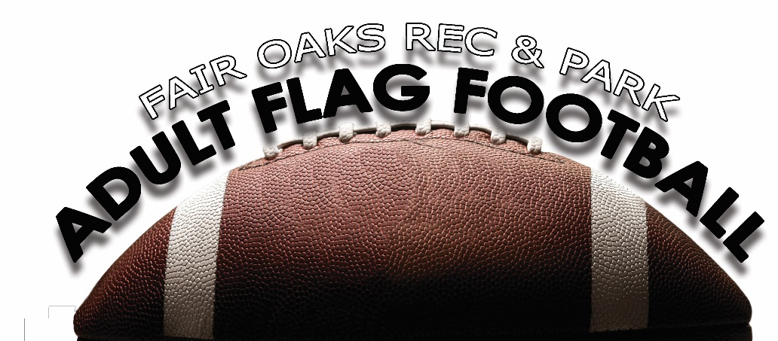

FAIR OAKS RECREATION & PARK DISTRICT
ADULT FLAG FOOTBALL RULEBOOK 2018
7 on 7 Passing League only
ATTIRE
- Cleats are allowed, except for metal spikes. Inspections will be made. No bare feet or open-toes shoes allowed. Pants/shorts without pockets or taped closed are also required.
- All players must wear protective mouthpieces; there are NO EXCEPTIONS. Players are responsible for supplying their own mouthpiece.
- All players must wear appropriate matching team colors.
- Players are not allowed to wear jewelry, hair barrettes, hats, casts or any hazardous items. All unauthorized items must be removed before start of game.

GETTING STARTED
- A coin toss determines first possession. Winner of coin toss gets to choose one of the following:
• Choose to start on offense or defense
• Side their team will defend
• The other team will get the choice that is not picked
• Both teams will do the opposite in the second half (direction and offense or defense)
- Game length is two, 20 minute running halves. Each team is allowed two, 30 second time-outs per half. There may be an official time-out to assist an injured player at the discretion of the referee.
- There will be a 5 minute halftime.
- Teams can start with (5) players. Anytime a team drops below the minimum (5) players they will have to forfeit.
- The offensive team takes possession on its five (5) yard line and has four (4) plays to cross the first down marker. If the offense fails to make a first down, the ball changes possession and the new offensive team takes over on its own five (5) yard line. Ball must be snapped between the legs, not off to the side, to start play.
- If a team has the lead with the ability to “run out the clock” the game is over. (There is no mercy rule)

DURING THE GAME
- All possession changes, except interceptions, start on the offense’s five (5) yard line.
- Prior to the start of the 2nd half, teams change sides with possession of the ball going to the team that started the game on defense.
- Each time the ball is spotted, a team has 30 seconds to snap the ball.
- The offensive team is allowed one player (QB) off the line of scrimmage.
- This is a PASSING LEAGUE. NO HANDOFFS. No handoffs are allowed at any time including flea flickers.
- The QB has 7 seconds to release the ball from the time of the snap.
- Passes must be beyond the line of scrimmage.
- All players are eligible to receive a pass unless the player voluntarily goes out of bounds during the play.
- Only 1 offensive player may be in motion at the time of the snap this motion must not be toward the line of scrimmage.
- If two or more players go in motion before the snap, this is considered a shift and all players must come set for 1 full second prior to the snap.
- The center, after assuming the position for the snap and adjusting the ball, may not move nor change the position of the ball in a manner simulating the beginning of a play.
- The ball must be snapped in one continuous motion.
- The ball must touch the ground before snapping the ball.
- You can receive the snap from shotgun or directly under center.
- A player is consider down if any part of his body except hands, touches the ground.
- Interceptions can be run back. This is the only change of possession that doesn’t get marked on the offense’s five (5) yard line.
- Fumbles are ruled as a dead ball at the spot of the fumble. Fumbles are not playable balls once in contact with the ground.
- No tackling, holding, striping, pushing or over excessive roughness is allowed.
- Spinning is allowed but players feet may not leave the ground.
- Flag guarding is illegal and will include penalty yards. Flag guarding consists of blocking a defender from access to your flags. This can be with a hand, arm, football or jersey.
- When an inadvertent whistle is blown by an official, the ball is dead at the point when the whistle is blown and play must resume from that point.
- Offensive player may not run over a defender who has established position.
- No Stripping of the ball

BLOCKING
- No blocking or “shadow” blocking is allowed.
- Any attempts to cause “hard contact” between players will result in an illegal contact penalty which can be upgraded to unsportsmanlike conduct if the hard contact is considered malicious.
- Offensive players cannot impede the defender’s opportunity to make a play on an offensive player. Crossing routes are permitted. However, if it appears to the official an offensive player is blocking (purposely getting in the defenders way on a route) a penalty can be called.

RUSHING THE QUARTERBACK
- All players who rush the quarterback must be a minimum of ten (10) yards from the line of scrimmage when the ball is snapped. Any number of players can rush the quarterback.
- Players not rushing the quarterback may defend on the line of scrimmage.
- Offense cannot impede the rusher in any way. The rusher must have a CLEAR PATH to the QB and any interference that would impede his/her path to the QB will be considered an illegal pick.

DEAD BALLS
- Substitutions may be made on any dead ball.
- Play is ruled “dead” when:
Ball carrier’s flag is pulled.
Ball carrier’s flag falls off.
Ball carrier steps out of bounds.
Ball carrier’s knee hits the ground.
Seven (7) second passing rule comes into play
Ball is fumbled
Touchdown or safety is scored.

FLAG RULE
- If a receiver’s flag falls off their waist while running a route, they are still eligible to catch a pass but are down where he catches the ball.
- If flags fall off a player while he has possession of the ball and is running down field, the player is down at point of lost flag.
- If a Quarterback begins the play without a flag the player is down at the spot of contact with the ball.
- A receiver can being the play without a flag but is down at the spot of possession
- All Flags must be in position on the start of the play
- Any player with a shirt over the flags (Not tucked in) will be down at the spot of possession

OVERTIME
- A coin toss determines first possession. The team losing the toss will determine which end zone to defend. Each Team will get one attempt to either go for 1 point (from 5-yard line) or 2 points (from 15-yard line). The team that has the most points after their possession will win. If the game is still a tie after the overtime, the game will end in a tie.

SPORTSMANSHIP/ROUGHING
- If a referee or program staff member witnesses any unsportsmanlike conduct such as, but not limited to, tackling, elbowing, cheap shots, blocking, or actions deemed inappropriate to the game, the game will be stopped, the referee will assess a penalty and the player will be excused from the game.

FOUL PLAY WILL NOT BE TOLERATED
- Trash talking is forbidden. Officials have the responsibility to determine offensive language, gestures or actions. (Trash talk is talk that may be offensive to officials, opposing players, teams or spectators.) If trash talking occurs the referee will assess a penalty for unsportsmanlike conduct and warn the offending player or coach. If it continues, the offender(s) will be excused from the game.
- The purpose of Fair Oaks Recreation & Park District programs is to promote and encourage safe and positive leisure time activities for all participants.
- Showboating is not allowed and a warning will be given but may be upgraded to an unsportsmanlike conduct penalty.

EJECTION’S AND SUSPENSIONS
- Any player ejected from a game will be suspended for a minimum of one (1) game, possibly longer if warranted. In addition to the ejection, the suspension will be served at the next scheduled game.
- Any coach/spectator ejected from a game will be suspended for a minimum of one (1) game, and may be removed entirely from the program and future programs if necessary.
- The program coordinator reserves the right to remove any player/coach/spectator from the program that creates an unsafe or negative act during the program time.

PENALTY YARDS

Defensive

A. Offsides/Encroachment – 5 yards and repeat the down.

B. Pass Interference – 10 yards from the line of scrimmage and automatic first down.

C. Illegal contact (holding, blocking, etc.) – 10 yards and automatic first down.

D. Illegal flag pull (before receiver has ball) – 10 yards and automatic first down.

E. Illegal rushing (starting rush inside 10 yard marker) – 10 yards and repeat the down

F. Roughing the Passer (incidental & accidental) – 15 yards and automatic first down.

G. Unsportsmanlike Conduct – 15 yards, automatic first down and possible ejection H. Extra point tries (any defensive penalty) – Offense retains possession with the ball placed half the distance to the goal line.

I. Half cannot end on a defensive penalty

Offensive

A. Illegal motion (more than one person in motion, false start, illegal shift) – 5 yards from the line of scrimmage.

B. Offensive pass interference (illegal pick play, pushing off/away defender) – 10 yards from the line of scrimmage and loss of down.

C. Illegal Forward Pass (pass thrown behind line of scrimmage) – 5 yards and a loss of down.

D. Flag guarding – 5 yards (from the spot of the violation) and loss of down.

E. Delay of game – (After last offense play the new play has to start within 30 second or it will be a delay of game). 5 yards and loss of down.

F. Intentional grounding – 10 yard penalty and loss of down.

G. Intentional grounding in the end zone – Safety
H. Unsportsmanlike Conduct – 15 yards, automatic first down and possible ejection
SCORING
Touchdown = 6 points
Conversion from 5 yard line = 1 point
Conversion from 15 yard line = 2 points
Safety = 2 points

