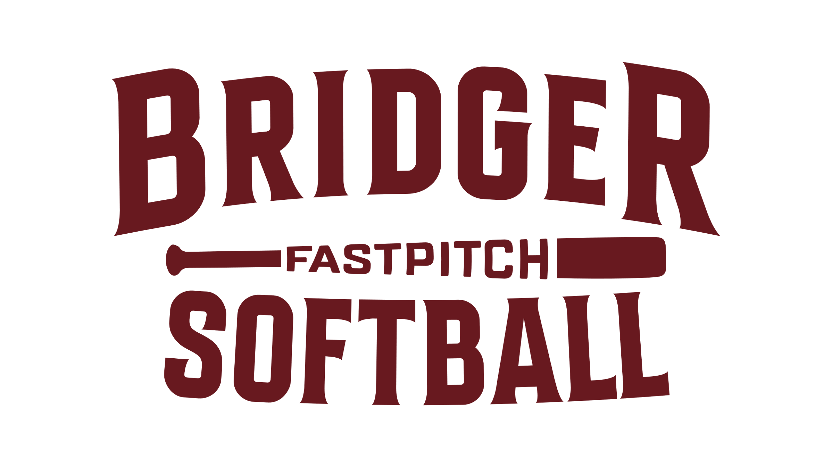
Bridger Softball Sponsorship Form
Donate today and become a sponsor at one of our various levels.
Sponsorship Level | Cost | What’s Included | Selection
Silver | $250 | - 1 year team sponsorship  - 3x5 banner on one field  - Link to business on website  - Recognition on Facebook page
Gold | $500 | - 1 year team sponsorship  - 3x5 banner on two fields  - Link to business on website  - Recognition on Facebook page
Platinum | $1000 | - 1 year league sponsorship  - 3x5 banner on two fields, plus large roadside banner  - Business name on team jerseys  - Link to business on website  - Recognition on Facebook page

Company/Representative Name: ________________________________ Phone: ____________________

Address: _____________________________________________________________________________

City/State/Zip: _________________________________________________________________________

Over 1,000 players and parents visit our softball complex each year. Signs and banners are displayed at all events held at the complex.
Please respond quickly by completing this form and sending it in today!

Send form to: | Make checks payable to: | Send artwork/graphics to:
ABE Softball  PO Box 5  Baden, PA 15005 | ABE Softball | ABESoftballBoard@gmail.com

Bridger Softball is a 501(c)(3) organization. All sponsors will receive a receipt for their tax-deductible donation. Platinum sponsorships must be received by 3/5/2022.

