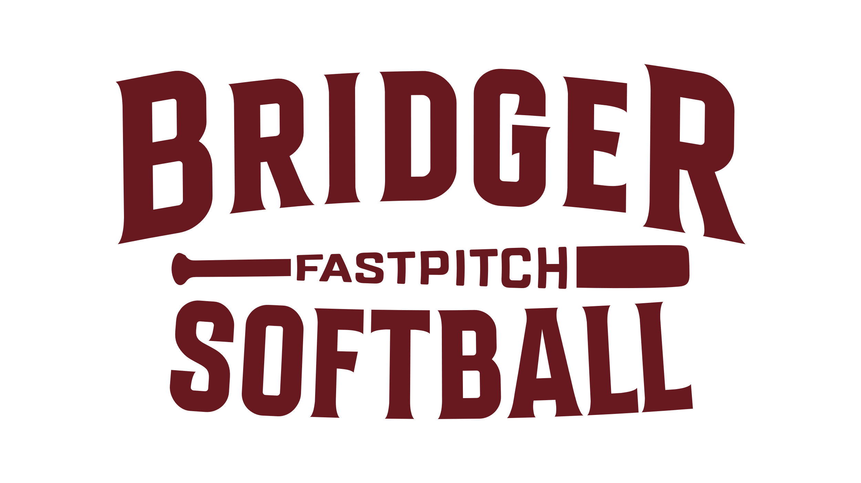

Required Background Checks for Bridger Softball Volunteers

- Pennsylvania State Police Background Check
New Volunteer Background Check

- Childline Clearance
https://www.compass.state.pa.us/cwis/public/home
Please apply to each as a "volunteer." There should be no charge when you apply as a volunteer.

- Concussion Education
https://nfhslearn.com/courses/61129/concussion-in-sports

Coaches must complete all three (3) to coach on a Bridger Softball team.

