CBC registration due: before coaches meeting
Thank you for volunteering to coach.
There are three requirements that must be completed to be a volunteer coach for this season:

- Assignment for year and seasonal sport ie Spring 2025 (Step #2)
- Criminal Background Check (ss# submitted and/or not expired)
- Athlete Protection training (not expired)

ALL volunteer coaches must register for a Criminal Background Check (CBC) for seasonal sport; ie SPRING 2025. Yes, even RETURNING coaches!
RETURNING COACH: Must register to add the seasonal; ie 2025 SPRING, sport in their assignment in Dallas YMCA Volunteer Matters. Update ss# and/or retake Athlete Protection
NEW COACH: Sign up for a new account in Dallas YMCA Volunteer Matters and Great Academy for a CBC registration and complete Athlete Protection (AP), in Great Academy.
For CBC and AP registration (Use Chrome browser. Pls use your Desktop. If you use your phone, AP training may not open up.):
- Visit: https://ymcadallas.volunteermatters.org/project-catalog/375

- SCROLL down and click “Volunteer” for the sport and season you are coaching ie: 2025 SPRING Flag Football
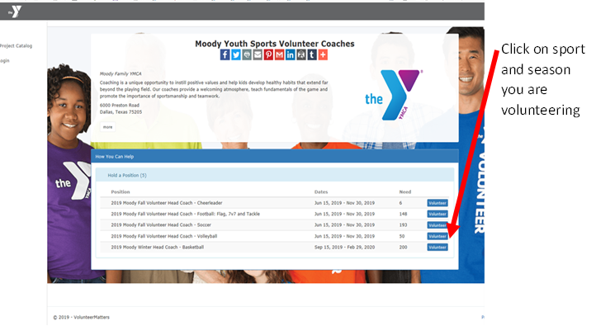
3. Click “Register Now” for NEW coaches; RETURNING coaches - Login using your user and pw & Hit Apply Now
4. Write down or save your user login and password for future reference.
5. Complete the registration and read/sign each credential
6. CBC SS#:
- NEW: Enter your 9 digit ss# (If it only asked for your last 4 digits, you did not assign yourself to volunteer position, Step 2 above.)
- RETURNING: Enter your 9 digit ss# IF it asks you.
7. Click “Continue”.
8. Complete Athlete Protection (AP) – Part 1 and Part 2
- If Athlete Protection is required, expired, incomplete or cancelled, look for the continue button in any of the three views pictured below. The link will take you to Great Academy for the online training course, Athlete Protection (AP).

​​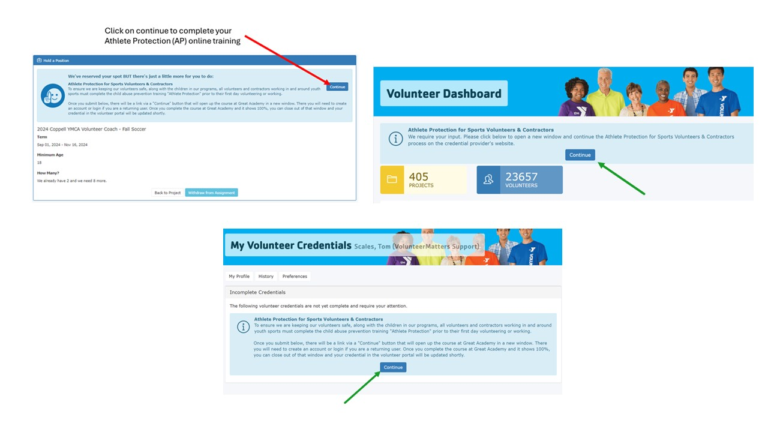
​​
- Returning volunteers will sign in using the blue button pictured with the arrow on the left. New volunteer accounts will sign up a new registration using the ‘Sign up here’ in the light blue area pictured with the arrow on the right. Use the same user, pw and email from Volunteer Matters.
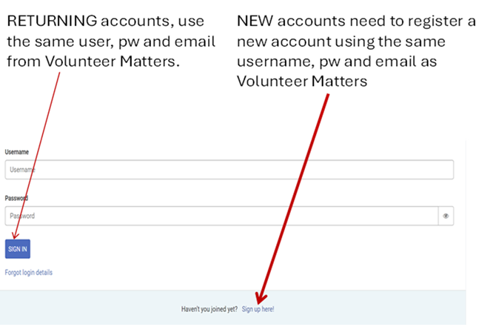

​
- Enter your information the same information from Volunteer Matters.

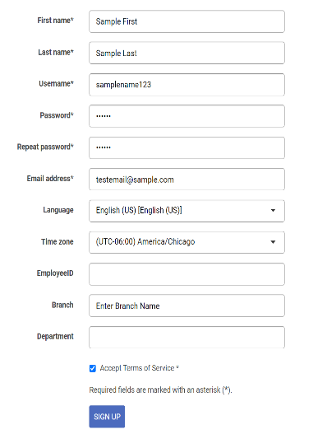
Type your name exact same way you entered it in Volunteer Matters. Use the same username, pw and email from Volunteer Matters.
Enter the name of the YMCA branch you are volunteering

- Start your Athlete Protection Part 1 and Part 2. Email your completion certificate to mmacgregor@ymcadallas.org . Then go back to your Volunteer Matters browser.

9. You will get this message. Make sure you have no additional requirements to complete:

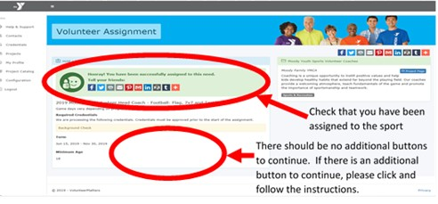
Verify yourself that you are a volunteer coach compliant when you satisfy all four below:
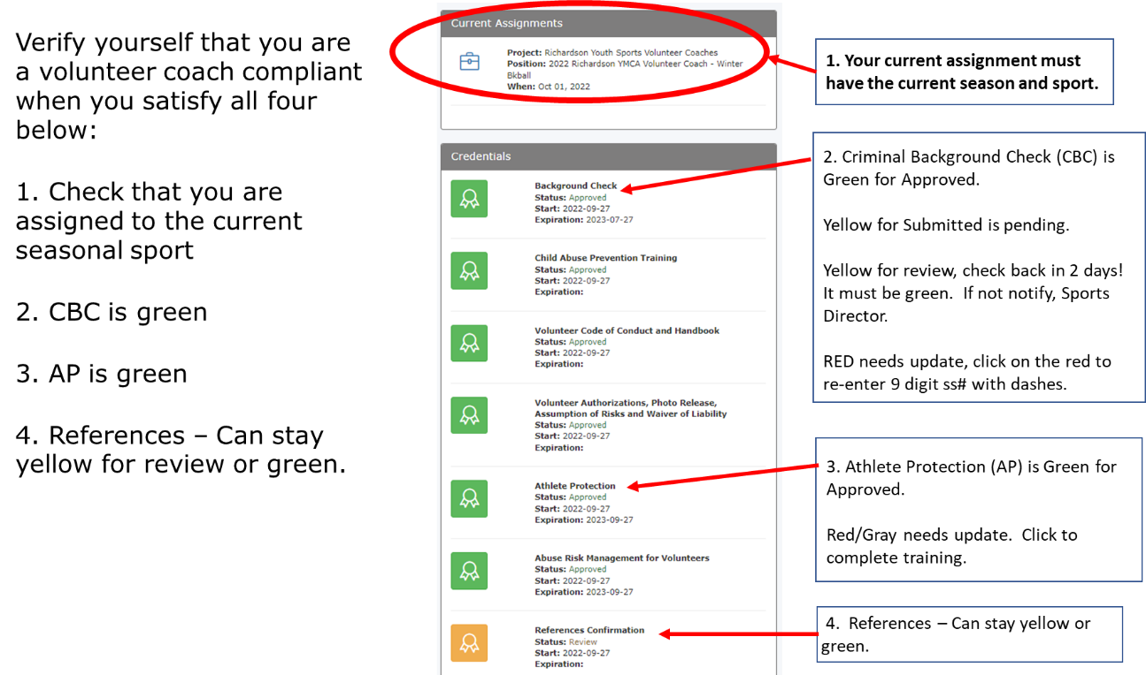
If you have any questions, please contact May MacGregor, Sports Specialist Director, at 214.221.9622 x3773 or at mmacgregor@ymcadallas.org.

Thank you,

May MacGregor
Sports Specialist Director YMCA of Metropolitan Dallas
214.221.9622
Lake Highlands Family YMCA
8920 Stults Rd
Dallas, Texas 75243

