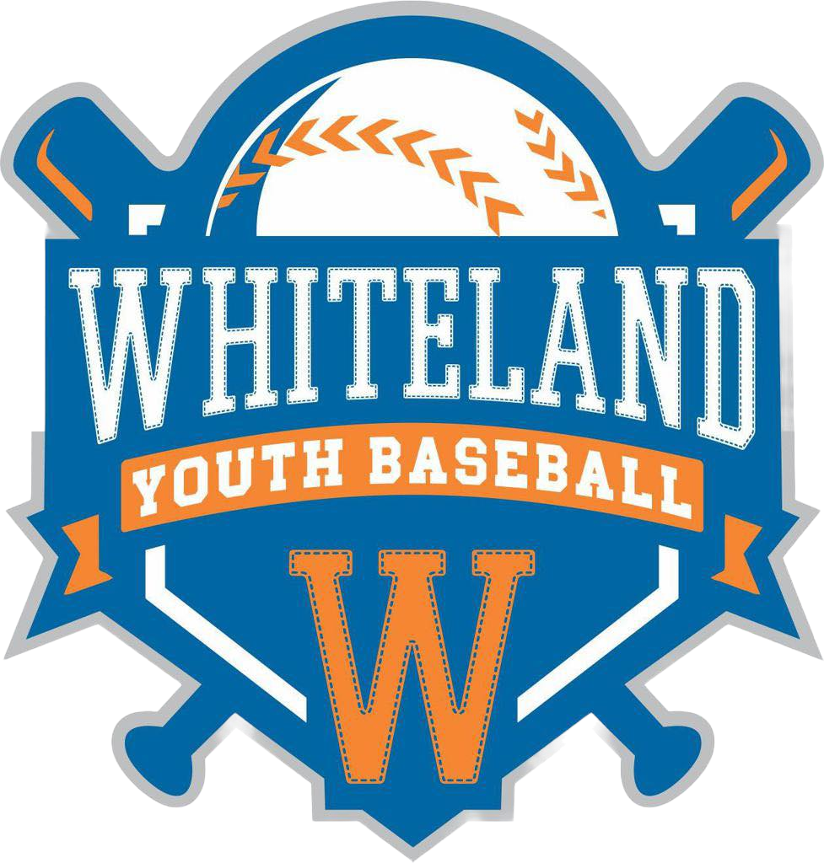
Sponsorship Levels 2026
General Sponsor (1 Banner) $ 300.00
1 Banner/Sign in Outfield with Business Name and Logo
Recognition on WYB Website with Link to Business Website
Game Day Announcement Recognition
(1 Additional Banner can be added for additional $100.00)
Team Sponsor $ 500.00
1 Banner/Sign in Outfield with Business Name and Logo
Recognition on WYB Website with Link to Business Website
Game Day Announcement Recognition
Business Name or Logo on Sleeve of Team Jerseys for one team
Team Plaque at the end of the season
Equipment Sponsor $ 750.00
1 Banner/Sign with Business Name and Logo
Recognition on WYB Website with Link to Business Website
Game Day Announcement Recognition
1 Team Sponsorship – Includes all Team Sponsorship Perks
Concession Stand Sponsor $ 750.00
1 Banner/Sign on concession stand with Business Name and Logo
Recognition on WYB Website with Link to Business Website
Game Day Announcement Recognition
1 Team Sponsorship – Includes all Team Sponsorship Perks
Field Sponsor $1,000.00
Naming Rights to 1 Baseball Field for Current Season
1 Large Banner/Sign behind home plate with Business Name and Logo
Recognition on WYB Website with Link to Business Website
Game Day Announcement Recognitions
1 Team Sponsorship – Includes all Team Sponsorship Perks
Option for Ceremonial 1st Pitch on Opening Day on your Field
Park Sponsor $5,000.00
Naming rights to the ballpark (1 year term)
Sign at the entrance of the baseball park with Business Name and Logo
Signage throughout the ballpark.
Recognition on WYB Website with Link to Business Website
Game Day Announcement Recognition
1 Team Sponsorship – Includes all Team Sponsorship Perks

