
Registration document upload procedures
Please follow these instructions to upload the Player’s “Birth Certificate” or “School Enrollment Form”.

-First step is to scan and save the individual documents in a folder easily accessible. (this can be a scanned pdf or take a picture as a JPEG)
-Once the documents are saved, follow these instructions to upload into the player’s record on Team Sideline.
- Go to NNLL.org and click on the “ENROLL” button.
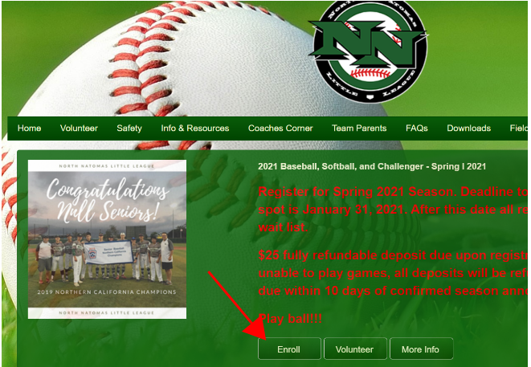

- Sign into your Team Sideline account…
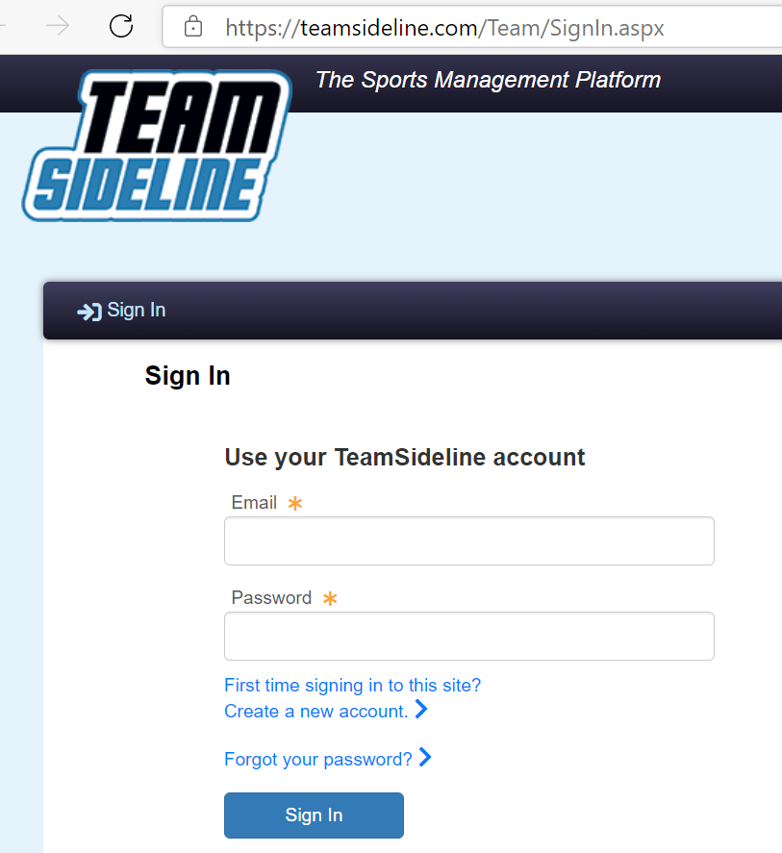
- Drop down the “My Account” menu and select “Members”
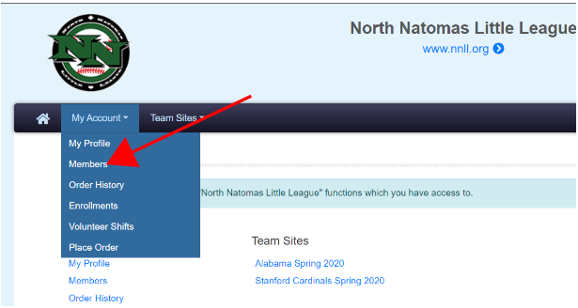

- Select the edit button for the player who you want to upload the document to…
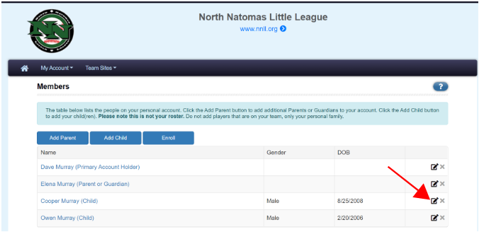

- Scroll down the page to select which document you want to upload…
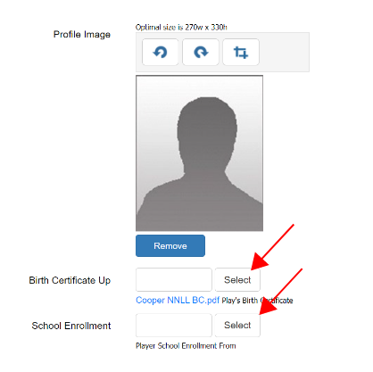

- Find document that you previously saved, double click it to insert and save when complete.
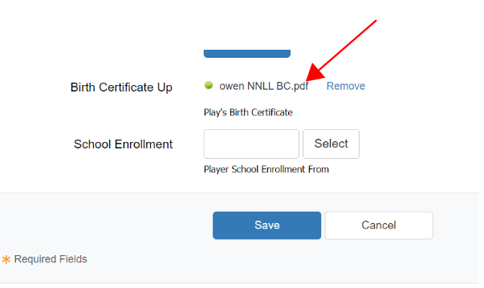

- That’s it. Repeat this process for multiple players in your account.

